**AUSTRALIA AND NEW ZEALAND MINISTERIAL FORUM ON FOOD REGULATION**

POLICY GUIDELINE ON NUTRITION, HEALTH AND RELATED CLAIMS

*Updated and endorsed on 29 June 2018*

# POLICY PRINCIPLES

The policy principles endorsed by Australia and New Zealand Ministerial Forum on Food Regulation (Forum) for nutrition, health and related claims for food provide that any intervention by government should:

1. give priority to protecting and improving the health of the population;
2. enable the responsible use of scientifically valid nutrient, health and related claims;
3. support government, community and industry initiatives that promote healthy food choices by the population;
4. be consistent with and complement Australian and New Zealand national policies and legislation including those relating to nutrition and health promotion, fair trading, industry growth and international trade and innovation;
5. be cost effective overall, not more trade restrictive than necessary and comply with Australia’s and New Zealand’s obligations under the World Trade Organisation (WTO) Agreements;
6. contain a process of substantiation which aligns levels of scientific evidence with the level of claims along the theoretical continuum of claims, and at minimum cost to the community;
7. draw on the best elements of international regulatory systems for nutrient, health and related claims and be responsive to future trends and developments;
8. provide for collaborative action among enforcement agencies, industry and consumers to optimise educational resources; and
9. allow for effective monitoring and appropriate enforcement.

The following features of any regulatory system for health, nutrition and related claims are also considered desirable. The system should:

1. favour pre-market approval rather than post-market reaction;
2. enable better engagement of sectors other than government in providing nutritional advice and information; and
3. promote a partnership between consumers, governments and industry in the delivery and responsible use of nutrition, health and related claims which protects consumers from false and misleading information that may result in distorted diets which harm health and increase health inequalities.

# CLAIM PRE-REQUISITES

Every health claim made must comply with the following, overarching policy principles, regardless of their claim classification level.

The overarching policy principles are:

1. Claims can be made providing:

* the food and/or component is safe for consumption in recommended quantities as part of the total diet;
* all requirements contained in Food Standards in the Australia New Zealand Food Standards Code are met;
* the claims have been scientifically substantiated;
* there is enough of the specified component to achieve the claimed benefit when consumed as directed;
* the eligibility criteria, including qualifying and/or disqualifying criteria (and any excluded categories of foods, such as alcohol and infant foods), are complied with;
* the claim is socially responsible and does not promote irresponsible food consumption patterns.

1. Except where permitted by the Food Standards Code, claims that a food or component of a food or diet can prevent, diagnose, cure or alleviate a disease, condition, ailment, defect or injury in humans would be considered therapeutic claims and are not permitted (e.g. eating this food protects you from getting ‘Q’ disease).
2. Claims that a food or component:

* influences performance and wellbeing;
* manages, influences, inhibits, or modifies a physiological process;
* reduces the risk of a disease, condition, ailment, defect, or injury;

1. may only be made in the context of the appropriate total diet (that must be described) *(e.g. This food contains ‘X’ which may improve ‘Y’ when eaten as part of a varied diet low in ‘A’ & ‘B’ and high in ‘X’ & ‘C’*).Claims about a food or component can describe a health benefit for the population but must not:

* imply or state a universal or guaranteed benefit for all individuals, except where permitted by the Australia New Zealand Food Standards Code;
* imply or state a health benefit for the population if the claimed benefit applies only to a particular subgroup of the population, unless the population subgroup is stated;
* lead a consumer to self-diagnose or self-manage a condition or disease that should be medically diagnosed and/or managed;
* encourage over-consumption of single foods or ingredients;
* state or imply that a healthy diet is reliant on the inclusion of a single food;
* arouse unwarranted and/or unrealistic expectations of the benefit to the individual;
* be alarmist. That is they cannot:
* contain language that could bring about fear or distress;
* lead the consumer to believe that they are suffering from a serious ailment or disease;
* lead the consumer to believe that harmful consequences may result if they do not consume the particular product.

1. A claimed benefit must be:

* achievable when the food is consumed in quantities which can reasonably be expected to be consumed daily as part of an appropriate total diet;
* derived from the food or component in question for which the claim is made and not from consuming the food with a combination of specific foods.

1. Claims must communicate a specific rather than a broad benefit (e.g. improves recovery from exercise rather than improves sport performance).
2. Claims that refer to:

* a disease, condition, ailment, defect or injury should include a statement explaining how the claimed benefit is achieved (e.g. high in ‘Z’, diets high in ‘Z’ do X which may reduce the risk of ‘G’ disease);
* the dietary management of a biomarker, condition or disease that may require the supervision of an appropriate health care practitioner, must have an advisory statement to the effect that a health care practitioner’s advice is required.

1. Where advisory or warning statements in relation to the claim are required, they must appear in close proximity to the claim in the same communication medium.
2. Where the information about the claim is separated into sections (split claim) the first part of the claim must direct the reader to further information provided elsewhere in the same communication medium.
3. In a compound claim any part of the claim that falls within a higher claim category results in the totality of the claim falling into that category.
4. Endorsement Programs that state or imply a nutrition, health, or related claim must comply with these principles and the requirements of the relevant category of claim. They will require a statement to explain why the endorsement has been granted (e.g. Meets nutrient criteria required by the endorsement program).
5. Marketing activities that promote charities or non-profit organisations (i.e. cause-related marketing programs) that relate to disease or health must have a disclaiming statement to ensure they are not interpreted as a nutrition, health or related claim.
6. Communication to health professionals of a nutrition, health, or related claim about specific food products or food types (e.g. milk, meat etc.) must comply with these principles and the requirements of the relevant category of claim.

# CLAIMS CLASSIFICATION CRITERIA

The claims classification framework sets out criteria for three levels of claims: nutrition content claims, general level health claims and high level health claims.

The categorisation of a claim is based on the degree of promise to the consumer of the claim. That is, the potential benefit to the consumer in consuming that food in preference to other foods and, commensurately, the degree of risk to the consumer (and public health) in following the advice of the claim.

The level of a claim, as determined by the claims classification framework, will determine to what degree the claim is regulated, including the nature of the evidence required for substantiation. Substantiation of claims requires consideration of the Australian Dietary Guidelines or the New Zealand Eating and Activity Guidelines. Flexibility in wording of claims should be considered, provided the overarching principles and claim pre-requisites are satisfied. Consideration should be given to including criteria for making each level of claim and any parameters (e.g. qualifying and disqualifying criteria, or exclusions for certain categories of food, such as alcohol and baby foods) should be specifically stated in the Standard. These parameters will be particularly important to the monitoring and enforcement of nutrition content claims.

## Nutrition content claims

Nutrition content claims are claims that describe or indicate the presence, absence or level of a nutritive or biologically active substance in that food. For example “*this food contains calcium*”.

## General level health claims

General level health claims may be pre-approved by FSANZ or self-substantiated by the supplier (please refer to section ‘Substantiation requirements’). A supplier can also make an application to FSANZ for a claim to be added to the list of pre-approved general level health claims. General level health claims do not reference a serious disease or a biomarker of a serious disease. That is, references to non-serious diseases would be allowed in this category, as would claims that make no reference to a disease at all. General level health claims are those which:

* refer to maintenance of good health or normal physiological processes (including normal growth and development, or maintenance or other like functions of the human body) (e.g. helps keep you regular as part of a high fibre diet). This includes claims that describe the component and its function in the body (e.g. Calcium is good for strong bones and teeth); or
* refer to specific benefits for performance and wellbeing in relation to foods (e.g. gives you energy for normal metabolism); or
* are whole of diet claims based on the Australian Dietary Guidelines or the New Zealand;Eating and Activity Guidelines which may refer to the relevant benefits as described in the associated Australian Dietary Guideline or New Zealand Eating and Activity Guideline background papers but do not refer to a serious disease or condition (e.g. *A healthy varied diet that includes plenty of fruits and vegetables supports heart health)* or
* describe how a diet, food or component can modify a function or body structure beyond its role in the normal growth, development and maintenance and other like functions of the human body but do not state or imply a serious disease (*e.g.*); *A healthy varied diet high in calcium and calcium containing foods is necessary for normal bone structure)* or
* refer to the potential for a food or component to assist in reducing the risk of or helping to control a non-serious disease or condition (*e.g. Chewing gum may neutralise plaque acids in the mouth* ).

## High level health claims

High level health claims must be based on a pre-approved food-health relationship as listed in the Australia New Zealand Food Standards Code. To make a high level health claim that is not in the pre-approved list, an application must be made to FSANZ.

High level health claims are those health claims which make reference to a serious disease, including:

* claims that refer to the potential for a food or component to assist in controlling a serious disease or condition (i.e. those referring to risk reduction or a reduction or improvement in health);

*E.g. this food is high in X, which as part of a diet low in saturated fat and high in soluble fibre may reduce your risk of heart disease.*

* claims that refer to the potential for a food or component to assist in reducing the risk of, or improving a serious disease or condition;

*E.g. This food is low in Y which may reduce your risk of having a stroke through Z.*

* are whole of diet claims which refer to a serious disease or condition based on the Australian Dietary Guidelines or the New Zealand Eating and Activity Guidelines which may refer to the relevant benefits as described in the associated Australian Dietary Guideline or New Zealand Eating and Activity Guideline Background Papers;

*E.g. A healthy diet that may lower your risk of certain kinds of cancer is one that is low in fats and includes fibre from a number of sources including a variety of fruits and vegetables, and wholegrain and bran cereals.*

* biomarker[1] maintenance claims;

*E.g. This food is high in Y which may help maintain healthy cholesterol levels through Z.*

* biomarker enhancement claims; and

*E.g. This food is low in Y which may reduce your blood pressure through Z.*

* biomarker claims that make reference to a serious disease.

*E.g. This food is rich in Y. In conjunction with Z, Y helps to maintain your healthy cholesterol levels and can reduce your risk of heart disease.*

# REGULATORY MODEL

It is recommended that the following arrangements apply to the regulation and monitoring of nutrition, health and related claims:

* the Australia New Zealand Food Standards Code sets out the high order principles of the health claims system, the definitions of nutrition content claims, general level and high level health claims, and provides prescriptive, individual detail for all types of claims. The standard may also set out qualifying and disqualifying criteria for the different types of claims and categories of foods which may be excluded from making claims (e.g. alcohol and baby foods).
* A guideline document would provide the majority of the detail surrounding all types of claims. This guideline will be designed to assist industry in utilising the system correctly.
* a ‘watchdog’ body would serve as the public face of the health claims system, and undertake a number of key tasks.
* jurisdictions would be responsible for receiving complaints in the usual way. Enforcement of the Health Claims Standard, including assessing possible breaches and undertaking prosecutions, would be the responsibility of the State/Territory and New Zealand enforcement agencies. Enforcement agencies would be responsible for coordinating action across jurisdictions, and informing the ‘watchdog’ body of complaints received and actions taken, and providing feedback on any perceived problems with the regulation of health claims.

The ‘watchdog’ would:

* assist FSANZ in the creation and maintenance of the guideline document (in consultation with stakeholders);
* provide recommendations to FRSC regarding proposed amendments to the Standard or the guideline document;
* receive complaints via a mailbox and refer any complaint to the relevant jurisdiction(s) for analysis and enforcement action;
* record complaints received (either directly by the watchdog or jurisdictions), and monitor enforcement actions undertaken by jurisdictions in response to those complaints; and
* provide periodic reports to FRSC.

A schematic representation of the proposed Regulatory Arrangements is provided at page 8 of this guideline.

The Implementation Subcommittee for Food Regulation (ISFR) will act as the Health Claims ‘watchdog’. ISFR consists of an official from the Australian, the New Zealand and each State and Territory Government. ISFR will report to FRSC on enforcement and implementation issues and will also require a secretariat.

Consideration needs to be given as to whether these duties should be dealt with as a standing agenda item, or whether special, dedicated meetings should be convened to deal with Health

Claims watchdog functions.

It is recommended that the “watchdog” function be funded by jurisdictions on a pro-rata to population basis, similar to the AHMAC model. This would be re-assessed in a review to be undertaken two years after implementation of the standard.

## Advisory Panel

The proposed Advisory Panel is a register of independent experts set up under an administrative arrangement. The Advisory Panel would be available to jurisdictions on a cost-recovery basis.

Individual members from this panel would be available to assist enforcement agencies by providing their expert opinions on potential breaches, if requested. This could include advice on the adequacy of supporting evidence that food companies are holding to support their claims. The panel member would provide advice only, as opposed to an enforceable ruling, however they could be asked to assist in prosecution actions if required.

The Advisory Panel would also assist jurisdictions to build an enforcement capacity with regard to health claims during a fixed implementation period.

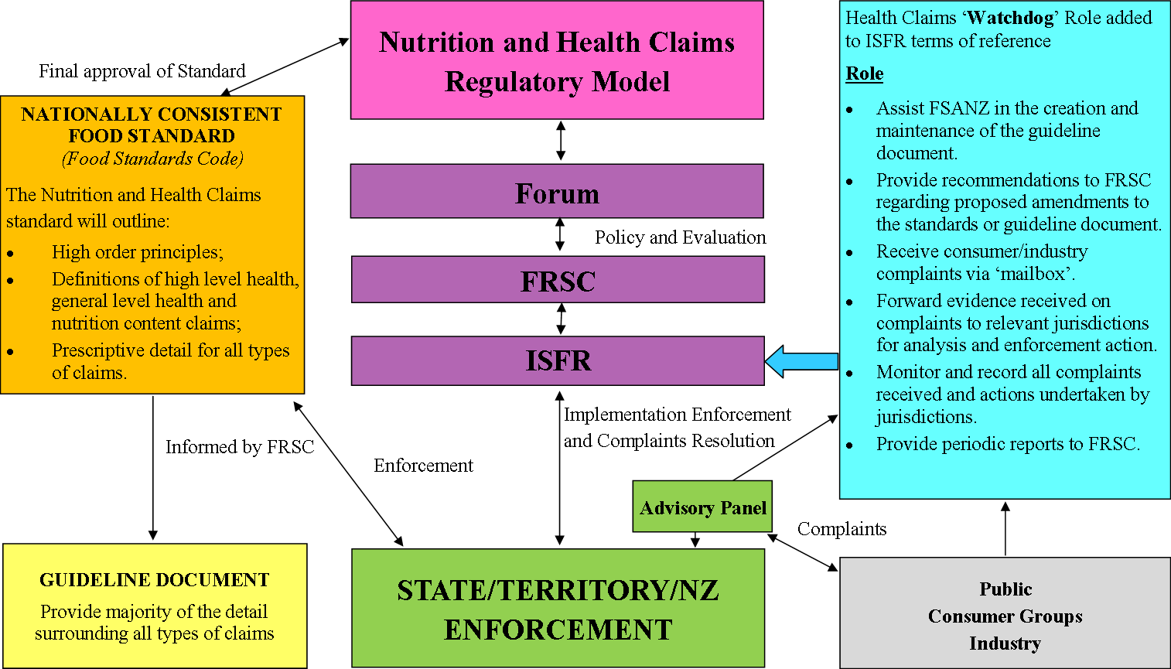

# SUBSTANTIATION REQUIREMENTS

It is recommended that consideration be given to the following requirements for the type of evidence to be held, and who is required to hold it, for each level of claim.

It is the responsibility of the food manufacturer to refer to the Standard and associated guidelines and make an assessment as to the classification of the claim they wish to use.

## Nutrition content claims

For nutrition content claims, the manufacturer needs to hold evidence that the product contains the relevant component(s) in the amount(s) being claimed, and to meet any qualifying or disqualifying criteria specified in the Standard.

## General level health claims

For general level health claims, there are two alternative requirements: where the evidence is 'consistently agreed' or where there is 'weight of evidence'.

**'Consistently agreed**' evidence for a claim refers to the conclusion that there is a sufficient body of sound, relevant scientific evidence that shows consistency across different studies and among different researchers. This body of evidence permits the key determination of whether a change in the dietary intake of the substance will result in an outcome consistent with the claim being made. For 'consistently agreed' evidence the manufacturer is required to hold appropriate scientific evidence of why and where the claim is substantiated, as well as evidence that the product contains an adequate amount of the relevant component(s).

**'Weight of evidence**' applies when the accepted scientific evidence for the claim outweighs any opposing evidence. Manufacturers will be required to hold this evidence in the form of a dossier consisting of:

* copies of the relevant studies;
* an outline of all the evidence available and a summary evaluation of the totality of evidence;
* together with evidence that the product contains an adequate amount of the relevant component(s).

The basic substantiation requirements will be set out in the standard, to ensure that they are enforceable, with links to additional, detailed guidance. The detailed guidance on evidence requirements and maintaining appropriate dossiers will be provided in the guideline document that will be developed by FSANZ in conjunction with ISFR and stakeholders. This guideline document will contain reference back to the standard, and will assist industry in complying with the requirements and due diligence. Manufacturers would have an obligation to ensure that the evidence used to make a claim has not changed, and, if further evidence comes to light, to reassess the validity of the health claim. Industry will be required to prepare their dossiers in advance of the claim being submitted to market and notified to FSANZ, and must produce this evidence on demand from enforcement agencies.

If a supplier wishes to make a general level health claim, they may choose to make such a claim based on ‘self-substantiation’ or based on one of the pre-approved claims listed in the Standard. A supplier can also make an application to FSANZ for a claim to be added to the list of pre-approved general level health claims.

**‘Self-substantiation’** As pre-market assessment and approval by FSANZ is not required, the supplier must assess the evidence supporting the claim prior to market, hold the records for the substantiation of the claim and produce these records at the request of relevant authority

**‘Pre-Approved claims’** Alternatively, suppliers may base health claims on one of the pre-approved claims listed in the Standard. See below for further detail on pre-approved claims.

**High level health claims** If a manufacturer wishes to make a high level health claim, this will need to be one of the pre-approved claims, unless an application to add a new high level claim to the standard is made to FSANZ.

**Pre-approved claims** based on dietary guidelines and other approved documents were assessed during the initial development of the Standard so that they are and were available when it commenced. If a manufacturer wishes to make a **high level health claim that has not already been approved**, an application will need to be made to FSANZ. Manufacturers will need to submit supporting evidence with their applications. This may include 'consistently agreed' evidence, ‘weight of evidence’, or emerging evidence. FSANZ will assess the evidence in accordance with statutory FSANZ processes. Approval by FSANZ, notification and acceptance by the Forum, and subsequent gazettal of variations to the standard will be required before the new high level health claim can be made.

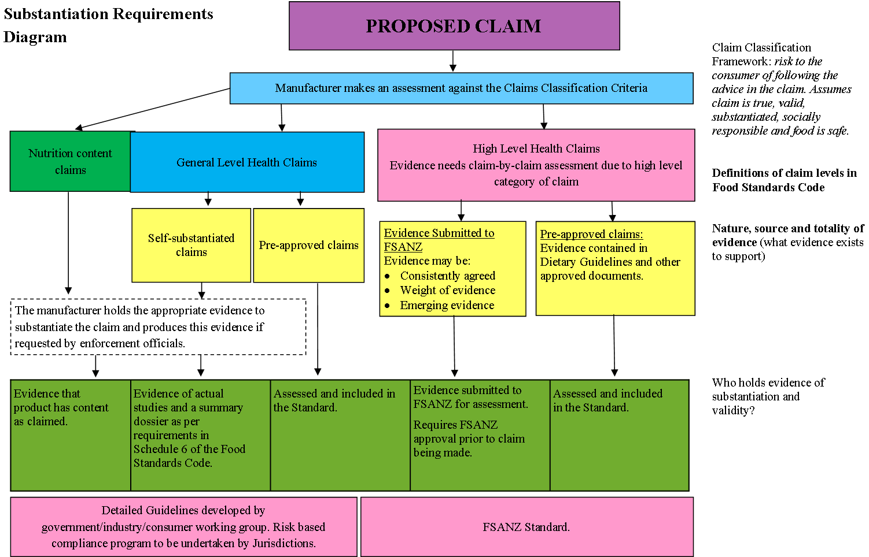

# ADDITIONAL GUIDANCE

* To ensure the system protects public health and safety, whilst assisting and encouraging industry the following recommendations are made: **A communication strategy** to educate and inform the food industry about what is expected under the new framework, to reduce the risk of inappropriate claims. This includes a clear strategy for nutrition content claims, general level health claims and high level health claims, as well as guidance on the forms of media captured in the framework (i.e. internet etc.).
* **Compliance and enforcement** to be closely monitored, with claims referring to a biomarker being a particular priority. Jurisdictions also need to make audits and enforcement a priority, particularly during the introductory period. The Advisory Panel would be available on a user pays basis to jurisdictions needing timely, expert advice. The watchdog body would report to Ministers on the use of biomarker claims and other enforcement issues within 6 months of commencement.
* **Work on pre-approved claims** will be concurrent with the development of the standard. It is envisaged that pre-approved claims based on the National Health and Medical Research Council (NHMRC) Australian Dietary Guidelines or the New Zealand Dietary Guidelines will be considered for inclusion in the Health Claims Standard from its commencement. For the purposes of reviewing the evidence for health claims, FSANZ should look to the NHMRC's recent independent evaluation of nutritional and dietary evidence in developing national dietary guidelines. **The standard should not prescribe exact wording** for the pre-approved general level and high level health claims. Some flexibility in the wording of claims should be permitted provided there is compliance with the Overarching Principles. In general, approval of high level health claims is to be 'claim by claim' and not 'product-by-product', although some products making high level health claims may have undergone separate pre-market approval to ensure safety under other standards. Again, it is envisaged that the Standard will not prescribe exact wording.
* **The Standard should provide sufficient detail to enable enforcement action** to be taken against all breaches, for all levels of claims. Both general level and high level health claims are to include specific pre-approved claims, whilst still allowing for flexibility in wording.
* Any costs associated with the ‘watchdog’ function should be funded on a pro-rata basis by jurisdictions. A model similar to the AHMAC model could be used. This will be reassessed in the review of the system.
* **A review** of the health, nutrition and related claims system should be undertaken within two years of implementation of the Standard. The review should take particular note of the effectiveness of the ‘watchdog’ body and its ongoing role (if any), the Advisory Panel and overall compliance of industry.

# GLOSSARY OF TERMS

It is recommended that consideration be given to the list of definitions for inclusion in the standard and any other guidelines.

**Biomarker:** any parameter from which the presence, absence or risk of a disease can be inferred by the level of the parameter (rather than being a measure of the disease itself.)

**Claim:** a stated or implied nutrition, health or related claim that can be communicated through all mediums including statements, symbols, vignettes, print or electronic media, or other forms of communication and or advertising.

**Component:** a component of a food includes a nutrient (including phytonutrient), non-nutrient or other ingredients.

**Compound claim:** a claim containing two or more clauses that can stand independently. The clauses are often linked by a conjunction such as ‘and’, ‘by’, ‘but’ etc.

**Conditions or diseases that are medically managed:** conditions and diseases in which a health care professional would be expected to prescribe and manage therapeutic treatment and monitor progress.

**Dietary management of a disease:** the selection of foods or food components to optimise the health of an individual with a specific disease or condition.

**Disease:** an unhealthy condition characterised by clinically significant signs or symptoms.

**Dosage:** a measured quantity administered at any one time or at stated intervals. A statement about dose or dosage would be considered a therapeutic claim and is therefore not permitted on foods. However, a manufacturer is allowed to state the amount of a component in a serving of the food together with the amount required to be consumed daily to achieve the desired effect. Specified serving sizes should reflect a realistic amount of the food that a person might normally consume. (e*.g. a serve contains Xg of the component. Consume Y* *serves per day, which as part of the appropriate total diet provides the claimed benefit*).

**Eligibility criteria:** before a food is permitted to carry a claim, all stipulated eligibility criteria for that food must be met. Eligibility criteria can include qualifying and disqualifying criteria, such as the requirement for the presence and/or absence of components in the food or entire food categories.

**Endorsement program:** in the commercial sense – an advertising testimonial: an instance of public endorsement of a product for advertising purposes.

**Nutrition, health and related claims:** include all claims referring to nutrient content, nutrient function, enhanced function, reduction of disease risk or maintenance of normal health.

**Serious disease or condition:** forms of diseases, conditions, ailments or defects which are generally accepted to be beyond the ability of the average consumer to evaluate accurately and to treat safely without regular supervision by a suitably qualified health care professional.

**Socially responsible:** meets ethical and moral standards and does not abuse the trust or exploit the lack of knowledge of the general public or contain language which could bring about fear or distress.

**Therapeutic claim:** a claim outside the context of the total diet that a specific food or food component will prevent, diagnose, cure or alleviate a disease, ailment, defect or injury; or influence, inhibit or modify a physiological process. Therapeutic claims on foods are not permitted under the Nutrition, Health and Related Claims framework, except where expressly permitted in the Food Standards Code. In Australia therapeutic claims may only be made for goods which are regulated by the Therapeutic Goods Administration. A statement about dosage is an implied therapeutic claim and is therefore not permitted on foods.

**Whole of diet claims:** claims which communicate the appropriate total diet required to achieve the stated benefit.

1. A biomarker is one indicator of a person’s risk of developing a serious disease (eg blood cholesterol is a biomarker for the risk of heart disease).