|  |
| --- |
|  |
| **Australia’s Foodborne Illness Reduction Strategy 2018‒2021+** |
| A strategy to reduce foodborne illness in Australia, particularly related to Campylobacter and Salmonella |
|  |

**AUSTRALIA’s Foodborne Illness Reduction Strategy 2018–2021+**

In April 2017 the Australia and New Zealand Ministerial Forum on Food Regulation (the Ministerial Forum) agreed the Food Regulation System is producing strong food safety outcomes overall and identified three priority areas for 2018 to 2021 and beyond to further strengthen the System.

One of these priorities is to reduce foodborne illness, particularly related to *Campylobacter* and *Salmonella.* Ministers requested the development of an Australian strategy, noting New Zealand has an existing strategy, and recognised success requires concerted national effort, collaboration and partnerships across the food supply chain.

The Ministerial Forum asked that the strategy be developed in consultation with stakeholders. The consultation was multi-faceted and used existing networks. States and Territories consulted at the local level and Food Standards Australia New Zealand (FSANZ) facilitated national roundtables that brought together industry sectors.

Consultation commenced on 12 February 2018 and closed on 6 April 2018. A total of 48 submissions were received from the following stakeholder groups: seventeen from industry organisations; two from consumers; one from a public health organisation; twenty from government organisations; eight from other stakeholder organisations. In addition, reports from five national forums and eleven jurisdictional roundtables were received.

A [summary of submissions](http://www.foodstandards.gov.au/foodsafety/standards/Pages/Food-Safety-Standards-(Chapter-3).aspx) is available on the Food Regulation website.

In general, submitters were supportive of the goal to reduce foodborne illness caused by *Campylobacter* and *Salmonella* by taking a thru-chain approach and focusing on improving food safety culture in the targeted sectors (food service, horticulture, eggs, poultry). Some submitters encouraged establishing a baseline or appropriate level of protection so quantitative reduction targets beyond 2021 are set.

There was broad agreement that more needs to be done to manage food safety risks in horticulture with a focus on education, culture and upskilling. It was agreed that the key high-risk horticulture products were: ready to eat, minimally processed fruits and vegetables; sprouts; fresh leafy green vegetables; melons; and berries.

Submitters reflected that the draft strategy did not include reference to the threat of antimicrobial resistance. This is because the food system engages, where relevant, via the Australian Government's National Antimicrobial Resistance Strategy 2015-2019.

Similarly, it was noted that allergens were not a defined hazard. Australia currently has an international leadership role through its chairing of a Codex Alimentarius working group developing a Code of Practice for allergen management. Through this and consolidating existing information, national information resources for allergen management emerge.

Submitters, particularly those from the targeted sectors, emphasised the importance of national engagement to track progress and design interventions collaboratively.

Consistency in the interpretation of standards, legislation and guidelines was a common theme.

# FRAMEWORK

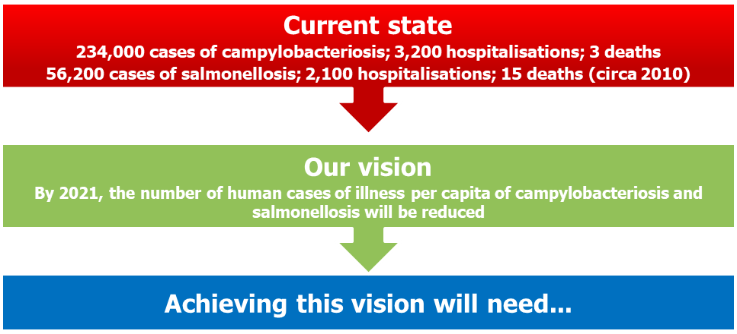

* action at all points along the food supply chain
* working closely with industry to develop interventions and drive reform
* research and evidence driving innovation
* a regulatory system that focuses effort on critical outcomes and food safety culture
* to target to the most relevant parts of the food supply chain; that is, the poultry, egg and horticulture (minimally processed fruit and vegetables, leafy green vegetables, sprouts, melons and berries) industries; food service, and consumers

**This will involve…**

# Why a national strategy?

*Campylobacter* is the most commonly notified cause of gastroenteritis in Australia. The report *Foodborne illness in Australia – annual incident circa 2010* estimated the median number of domestically acquired cases of gastroenteritis due to *Campylobacter* (circa 2010) to be 234,000 cases, including 3,200 hospitalisations and 3 deaths (77% of these cases were considered to be via foodborne transmission). Compared to similar countries, both Australia and New Zealand have higher rates (Figure 1).

In Australia, foodborne illness caused by *Salmonella* has significantly increased over the past 20 years and, compared to many similar countries, we have one of the highest rates (Figure 2). There are an estimated 56,200 cases of salmonellosis (2,100 hospitalisations and 15 deaths) with 72% of these considered to be foodborne.

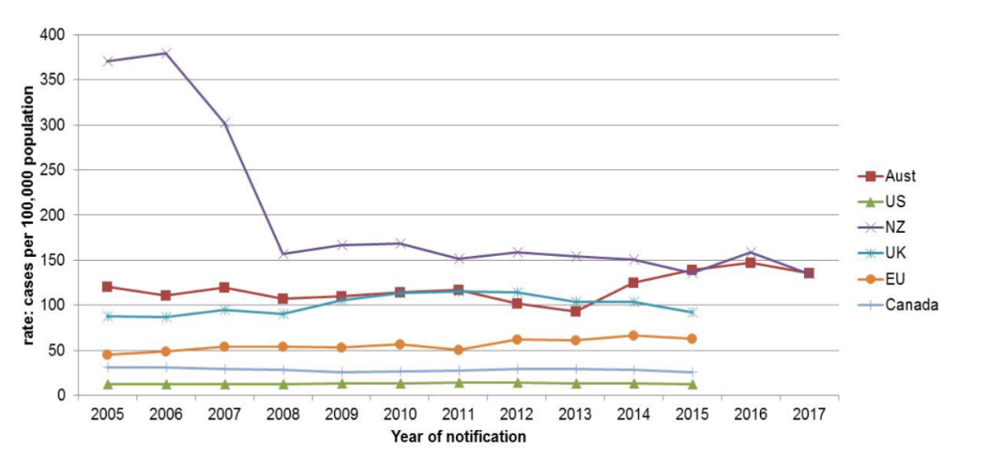

Figure 1: Campylobacteriosis notification rates in selected countries. The Australian rate does not include NSW infections which became notifiable on 1 April 2017. Source: Communicable Disease Network Australia

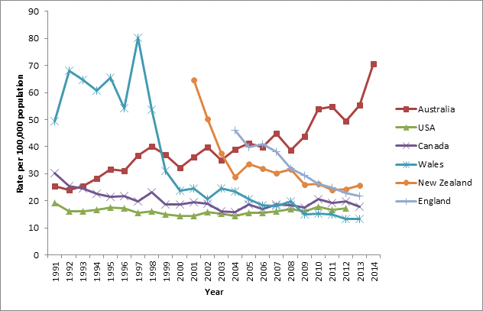

Figure 2: Salmonellosis notification rates (all serotypes combined) in selected countries. Source: Communicable Disease Network Australia

State and Territory health, agriculture and food authorities, and industry have implemented a range of regional risk management activities. At a national level, since 2013, key food regulatory interventions have included the implementation of primary production and processing standards, particularly in the poultry and egg industry sectors. Some states also developed state-based foodborne illness reduction strategies.

Foodborne illness is not a local issue and a coherent approach is required to tackle the challenges effectively. The experience of countries (New Zealand, United Kingdom, United States of America, and the European Union) that have focussed on reducing foodborne illness nationally indicates the best opportunity for success uses a targeted and coordinated approach with set health goals and follows a structured risk management framework.

# Goal

The aim of *Australia’s Foodborne Illness Reduction Strategy 2018-2021+* is to reduce the number of food-related human cases of campylobacteriosis and salmonellosis in Australia by 2021. The strategy aims to articulate more quantitative measures beyond 2021, through its focus over the next three years on better epidemiological and surveillance information and data on the impacts of *Campylobacter* and *Salmonella*. Implementation of the strategy presents an opportunity for gaining such information on notification rates and contributing factors.

## To achieve this goal, we will need…

### action at all points along the food supply chain from the farm to the consumer

The food chain for each commodity can generally be represented as follows:

Each stage contributes in a particular way to the level of pathogen in the end product, whether it is action on the farm, how a product is processed, or how it is handled by retailers and the consumer.

Interventions at different points will have a different impact on the final outcome and this can vary for each pathogen and for different industries.

### to work closely with industry to develop interventions and drive reform

Industry buy-in will be achieved through meaningful national engagement, sector by sector. Reform will also be successful if it enhances industry productivity. Accordingly, this strategy commits to establishing ongoing fora with industry to identify potential areas of improvement and to support the building of food safety culture within the food sector (see below).

### to maximise opportunities created by digital innovation and transformation

Digital transformation is now reshaping all aspects of society and the food industry is no exception. The connectivity of people with businesses; big data and analytics, artificial intelligence and the internet of things are trends that are rapidly disrupting businesses. These developments provide great opportunities to improve food safety by empowering the consumer and changing the relationships between businesses and regulators. Through effective engagement with innovative businesses, this strategy can incorporate these developments into practical solutions to food safety risks.

* **building a regulatory system that expects and promotes a food safety culture**

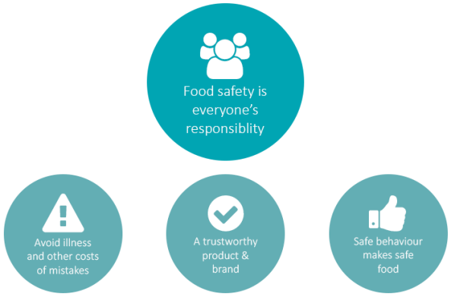

For regulators, it means that businesses achieve food safety outcomes because of their own commitment to food safety rather than relying on audits or inspections to identify risks, and penalties to enforce compliance. The Food Standards Code specifies minimum expectations to ensure food safety, and the broader food regulatory system promotes and rewards businesses with high-performing food safety culture.

### a fit-for-purpose regulatory system that focuses effort on critical areas for intervention

Standards should align with and support measures being developed by industry to improve food safety outcomes.

As innovative measures are identified, and shown to be relevant and have impact, the Regulatory System needs to adapt and adopt these measures so improvements are taken up across the entire food industry.

### research and evidence driving innovation

Actions taken under this strategy will be guided by evidence and research. Through the support of industry, jurisdictions and research bodies, universities are doing research that can improve the measures taken to control risks in the food chain.

To build our collective knowledge and drive innovation, it is essential to share knowledge and experience across the Food Regulatory System and with industry. New ideas and practices are already being considered, and this strategy needs to continue to support this innovation. We will also need to actively support the evaluation of new practices and dissemination of evidence.

By building linkages with researchers, it is hoped that research continues to inform practice and equally, that research priorities are informed by needs identified by jurisdictions and industry.

Shared Vision + Coordination and Collaboration + Evidence-based interventions

Partnerships
+
Tools and Processes
+
Research and Innovation

# The focus areas

Australia’s strategy to reduce the rate of foodborne illnessrelated to*Campylobacter* and *Salmonella* will be targeted to the most relevant parts of the food supply chain that is: the poultry, egg and horticulture industries; and food service. This will be supported by research, monitoring and surveillance, culture and education.

These actions include existing strategies that can be adapted and new initiatives that can be progressed in the short and mid to long term.

## National engagement

National industry specific forums will be established to support the implementation of measures outlined in the strategy, specifically: poultry, egg, horticulture and food services.

These forums will bring together government and industry to share planned activities to address *Salmonella* and *Campylobacter* through the supply chain and share outcomes. Both industry and jurisdictions will use their specific local stakeholder relationship processes to extend the reach of actions and learnings under this strategy.

States and Territories will use their processes to foster national consistency in approach so that the Food Regulation System has the flexibility to adapt to a dynamic food business environment**.**

## Food safety culture

Food safety culture in a business is how everyone (owners, managers, employees) thinks and acts in their daily job to make sure that the food they make or serve is safe. It's about having pride in producing safe food every time, recognising that a good quality product must be safe to eat.

A strong food safety culture comes from people understanding the importance of making safe food and committing to doing whatever it takes, every time. It starts at the top but needs everyone's support across the business.

FSANZ has developed information and resources for food businesses on food safety culture.

FSANZ will continue leading national activities with a broad range of stakeholders including food regulatory agencies from all levels of government and large and small food businesses, to promote and improve food safety culture.

Activities will focus on:

* Upskilling of authorised officers to close the gap between knowledge and application
* Working with educational institutions to recognise the importance of food safety culture in formal training
* Monitoring food handling behaviours
* Enhancing consumer knowledge gaps and behaviours that put them at risk

## Sector based initiatives

### Horticulture

The potential for pathogens to survive or grow in horticulture products is enhanced by their high moisture and nutrient content and the absence of a lethal process to eliminate pathogens in many products. International risk profiling combined with observations of local and global foodborne illness outbreaks identifies specific product-pathogen combinations to focus effort given the complex nature of the horticulture industry with its large variety of products and different production systems. The Codex Alimentarius Code of Hygienic Practice for Fresh Fruits and Vegetables turns specific attention to: ready-to-eat fresh pre-cut fruits and vegetables; sprouts; fresh leafy vegetables; melons; berries.

Managing pathogens in these products requires the control of food safety risks in horticultural supply chains. The Food Regulation Standing Committee is consulting with industry on fresh produce food safety management. The information gathered from these discussions is informing contemporary policy advice to ensure effective systems, interventions and partnerships are in place, and are maintained, to prevent and respond to foodborne illness involving fresh produce.

### Poultry

Food safety for poultry is covered by several standards in the *Australia New Zealand Food Standards Code* (Food Standards Code)*.* These standards aim to lower the incidence of foodborne illness by strengthening food safety and traceability throughout the food supply chain, from paddock to plate. The standards are:

* + Food Safety Standards ([Chapter 3 – Australia only](http://www.foodstandards.gov.au/foodsafety/standards/Pages/Primary-Production-and-Processing-(PPP)-Standards-(Chapter-4).aspx));
  + Primary Production and Processing Standards ([Chapter 4 – Australia only](http://health.gov.au/internet/fr/publishing.nsf/Content/australia-foodborne-illness-reduction-strategy-2018–2021)); and
  + Microbiological Limits for Food ([Standard 1.6.1](http://www.foodstandards.gov.au/foodsafety/standards/Pages/Microbiological-limits-for-food-(Standard-1.6.1).aspx)).

The Food Safety Standards have not been reviewed since their development in 2000. Under this strategy, there will be a review of the poultry meat primary production and processing standard to ensure it is being consistently implemented and the need for further guidance to provide greater clarify on any aspects, where necessary.

Industry and food regulatory agencies recognise that reducing the occurrence of pathogens like *Campylobacter* and *Salmonella* on raw chicken meat is an important strategy to reduce foodborne illness. For *Campylobacter* in particular, which does not tend to grow at the point of food service or in the kitchen, reducing its load on chickens in early points of the chain does seem to reduce the number of illnesses in the community. These efforts go beyond the minimum requirements of the poultry primary production and processing standard of the Food Standards Code.

In 2015-2016, FSANZ developed nationally consistent *Campylobacter* targets for raw poultry meat leaving the processor. Several jurisdictions have been actively working with poultry processors to identify and control critical processing operations to reduce outgoing loads of *Campylobacter*. Efforts will shift to national adoption of these poultry process hygiene criteria, national performance reporting and consistent triggers for action.

### Eggs

There is clear evidence from recent salmonellosis outbreaks associated with eggs that *Salmonella* requires control steps to be applied across several different parts of the supply chain. Actions to control the prevalence of *Salmonella* will be focussed on egg primary production and processing and in the use of eggs in the retail/food service industries, and in the home setting.

As with poultry, the primary production and processing standard for eggs has not been reviewed since its development. A review will ensure it is being consistently implemented and the need for further guidance to provide greater clarity.

It is also proposed to develop a nationally consistent approach to the recall of eggs.

### Food Service

Foods that contain raw or lightly-cooked egg are often used in restaurants, cafes, bakeries, catering and manufacturing food businesses and need extra care, as they can cause food poisoning if not handled correctly. Practices in food services settings were influential in increasing the number of people who became ill in salmonellosis outbreaks. To ensure the food is safe to eat, special attention must be given to the preparation, storage and handling of eggs and raw egg products, to prevent the growth of *Salmonella*.

Significant resources have been applied to this sector in all jurisdictions and national discussion and consideration of further regulatory and non-regulatory measures is progressing.

Implementing the *Ministerial Policy Guideline on Food Safety Management for the General Food Service and Closely Related Retail Sectors* to deliver nationally-consistent food safety management arrangements in these sectors is part of the national strategy.

## Consumer and industry education

Targeting of guidance and education for industry and consumers can be improved by consolidating existing and planned food safety information activities across jurisdictions. A communication plan will target ongoing issues related to consumer food handling behaviours and consistency of messaging on the role of handling storage and preparation of high risk foods.

New data could be generated on how current food handling practices contribute to *Campylobacter* and *Salmonella* transmission, particularly considering new technologies and food trends. The last study of this kind was in 2001. That study explored awareness of safe food handling practices and did on-site surveys of the extent to which these practices are used.

This strategy will require information on food business knowledge, practices and importantly, awareness and commitment to food safety culture. This will assist in identifying areas for targeted and collaborative strategies and initiatives. Food safety culture can be measured using a self-assessment survey with pinpointed food safety behaviours.

## Monitoring and surveillance

Knowledge of the foods responsible for illness comes mainly from outbreak investigations and case-control studies. Under appropriate information-sharing agreements, we could increase the intelligence from the data currently collected (but not publicly available) to understand trends and risk factors to prioritise the most effective food safety mitigations management for reducing foodborne salmonellosis.

Monitoring and surveillance systems must provide timely, comprehensive, systematic and integrated information to governments, industry and consumers so that appropriate public health and safety action can be taken. The system must nationally integrate surveillance data of foodborne salmonellosis and campylobacteriosis in humans, and data from monitoring of *Campylobacter* and *Salmonella* in food.

With regard to cases of human illness, the Nationally Notifiable Diseases Surveillance System (NNDSS) co-ordinates the national surveillance (from laboratories and clinicians) of more than 50 communicable diseases or disease groups. This includes all notified cases of human campylobacteriosis and salmonellosis in Australia.

Under the NNDSS, notifications are made to state or territory health authorities under public health legislation in their jurisdiction. Data is owned by individual jurisdictions. Computerised, de-identified unit records of notifications are supplied to the Australian Government Department of Health for collation, analysis and publication.

For contaminants in food, monitoring and surveillance occurs at different stages of the food chain and for various reasons. These may include routine testing of primary products, regulatory compliance, market access, verification of food safety programs, and national food surveys. Industry also monitors hazards in foods and data can be collected on a company - or industry-group level. The types of data collected, how it is collected and reported and when and how it is shared differs across government and between industry sectors. This data will be used to inform further measures which will require high level leadership.

Information-sharing arrangements between state and federal agencies and industry that can be used to target interventions, inform priorities and monitor progress will be established.

Enhancing linkages between the various agencies involved in human and food surveillance activities is a complex issue that cannot be resolved by simply changing the way information is collected or managed. All of this data is not in the public domain but could be accessed through trusted gatekeepers and under proper governance. This will require high-level leadership to drive the process and be supported by information-sharing agreements between state and federal agencies and information sharing arrangements with industry.

Other countries have established national systems for public health surveillance that rely on new tools such as whole genome sequencing for the rapid identification of outbreaks. Australia would benefit from having a similar system. A centralised and integrated system for compiling, trending and analysing data will improve our understanding of the impact of, and management of, *Campylobacter*, *Salmonella* and other pathogens of concern. Trends observed from public health surveillance and outbreak investigations, combined with intelligence from food monitoring and surveillance could be used to target interventions, inform priorities and monitor progress under this strategy.

## Research

Actions taken under with this strategy will be guided by research and evidence. To build our collective knowledge and drive innovation, it will be essential to share knowledge and experience across the Food Regulatory System, with industry and research bodies.

We will investigate the effectiveness and applicability of New Zealand’s *Campylobacter* national strategy to the Australian context. New Zealand implemented a national risk management strategy for *Campylobacter* in broiler chicken meat following an unacceptably high rate of foodborne campylobacteriosis in 2006, largely attributed to preparation and consumption of poultry meat. Their strategy’s main focus was on targeted quantitative hazard - and risk-based controls along the poultry chain, monitoring performance in meeting targets, safe food handling, and implementing controls with commitment from all sectors involved. New Zealand is now investigating additional transmission routes to further reduce the incidence.

A network of researchers, industry and government to more quickly maximise the value of research findings will be established. The network will provide a forum to:

* + guide investment in food safety research and development to reduce foodborne illnesses;
  + inform policy direction, preparedness and control options;
  + deliver diagnostic and surveillance services to help reduce the impact of foodborne threats;
  + improve market access; and
  + support sustainable economic growth.

A research network could be established under the FSANZ fellows program 1 in partnership with the Commonwealth Scientific and Industrial Research Organisation to facilitate the sharing of research outcomes between researchers, industry, regulators and the community and develop a national research plan to identify and consolidate key applied research targets.

# Implementation

The Food Regulation Standing Committee will be the governing body for implementing the strategy and reporting back to Ministers on progress.

The *Model Food Provisions* provides the overarching legislative framework for state and territory Food Acts. It is recognised that the review of the food safety standards in the Food Standards Code and the food safety management work in the food service and closely related retail sectors, once progressed, could inform considerations on the currency of the *Model Food Provisions*.

*The FSANZ Fellows program was developed to create a network of experts who can provide FSANZ with objective expert advice and critical review. The program also helps to develop academic links and networks.*