AUSTRALIA AND NEW ZEALAND MINISTERIAL FORUM ON FOOD REGULATION
POLICY GUIDELINE ON FOOD LABELLING TO SUPPORT CONSUMERS TO MAKE INFORMED HEALTHY FOOD CHOICES
August 2020

AIM
The Australia and New Zealand Ministerial Forum on Food Regulation (Forum) expects food labels to provide adequate information to enable consumers to make informed food choices to support healthy dietary patterns recommended in the Dietary Guidelines.

POLICY PRINCIPLES
- Food labels, should provide adequate information to enable consumers to identify foods that do and do not contribute to healthy dietary patterns recommended in the Dietary Guidelines.
- Information that enables consumers to identify foods that contribute to healthy dietary patterns recommended in the Dietary Guidelines is a public health priority and therefore sits towards the mandatory end of the ‘dominant mode of intervention’ within the preventative health section of the Food Labelling Hierarchy (see Appendix). Regulatory approaches for this labelling information should also be informed by the effectiveness or otherwise of co-regulatory measures to achieve the aim and policy principles in this document.
- Information that supports consumers to apply the recommendations in Dietary Guidelines should be provided on food labels in a format which:
- is easily accessed and understood by consumers;
- supports consumers to manage energy intakes to assist with achieving and maintaining a healthy body weight;
- supports consumers to compare foods;
- does not promote consumption of foods inconsistent with Dietary Guidelines (such as those high in saturated fat, added sugars, added salt and or foods with little or no nutritional value); and
- takes into account the nutritional content of the whole food, particularly risk nutrients identified in the Dietary Guidelines, so as not to mislead the consumer.

SCOPE
- This Policy Guideline focusses on food labelling to support the recommendations in the Dietary Guidelines that support the prevention of diet-related chronic disease. Recommendations about food safety and breastfeeding in the Dietary Guidelines are out of scope.
- This Policy Guideline applies to foods, beverages and alcoholic beverages.
- This Policy Guideline does not apply to infant formula.
- This Policy Guideline does not apply to foods for special medical purposes.
- While the focus of this Policy Guideline is information on food labels, should regulations for off-label information be considered, this Policy Guideline document should be taken into account.
- This Policy Guideline focusses on adequate food label information to enable consumers to make informed choices to support healthy dietary patterns. Where additional optional information is provided on a food label, other policy guidance may also be relevant, for example front-of-pack labelling or nutrition, health and related claims.

DEFINITIONS
For the purpose of this Policy Guideline:
- Dietary Guidelines – refers to the documents: Australian Dietary Guidelines, Australian Infant Feeding Guidelines, New Zealand Eating and Activity Guidelines and New Zealand Food and Nutrition Guidelines for other specified age and stage groups, or future iterations thereof.
- Dietary patterns – refers to types, combinations and amounts of foods eaten over a period of time.
- Recommendations – refers to the key overarching recommendations/statements in the Dietary Guidelines.
- Risk nutrients – nutrients identified in the Dietary Guidelines that increase the risk of obesity or diet-related chronic diseases.

CONTEXT

Dietary Guidelines
- Poor diet and overweight and obesity are leading risk factors for chronic disease in Australia and New Zealand. Dietary Guidelines provide guidance on foods, food groups and dietary patterns to support the prevention of chronic diseases and to achieve and maintain a healthy body weight.
- Dietary Guidelines make food-based recommendations (i.e. referring to nutritious foods and food groups such as fruit; vegetables and legumes/beans; and, grain foods, mostly whole grains; etc.), but in some instances the Dietary Guidelines make recommendations about foods based on the nutrients they contain (e.g. ‘limit intake of foods containing saturated fat, added salt, added sugars’ or ‘choose and/or prepare foods and drinks that are low in salt etc.).
- Many foods recommended in the Dietary Guidelines such as fruits and vegetables are not packaged foods and therefore are not labelled. These foods are an important feature of a healthy dietary pattern.
- While there are some differences between the Dietary Guidelines in Australia and New Zealand, the dietary patterns recommended in both Dietary Guidelines are largely consistent.
- The dietary patterns of the majority of Australians and New Zealanders are not aligned with the recommendations in the Dietary Guidelines,,.
- Consumer awareness of Dietary Guidelines is poor and as a result it may be difficult for consumers to understand how some foods relate to the recommendations in the Dietary Guidelines.
- To support consumer understanding and use of food labelling, there is a role for education and promotion of the Dietary Guidelines to raise consumers’ awareness and understanding about healthy dietary patterns.

Food labels
- It is recognised that food labels provide information about a specific food and its nutrients while Dietary Guidelines provide whole-of-diet recommendations about food groups and dietary patterns.
- Food labelling is one tool in the food regulation system that can enable consumers to make healthier food choices.
- Consumers choose foods for a variety of reasons, many of which are not health related,,. Food labels are one of many sources of information that may inform consumers’ choice of foods to eat. However, when consumers attempt to make healthier choices some find it difficult to use information on food labels to apply the recommendations of the Dietary Guidelines.
- The provision of adequate information relating to food to enable consumers to make informed choices is the second priority objective of Food Standards Australia New Zealand when developing or reviewing food regulatory measures and variations of food regulatory measures.

IMPLEMENTATION
- Any changes to food labelling informed by this Policy Guideline should be accompanied by consumer education activities to assist consumers to apply food labelling in the context of dietary patterns recommended in the Dietary Guidelines.
- Education activities should also recognise the role of unpackaged foods in healthy dietary patterns.
- Consistent and uniform enforcement of labelling regulations is also important to ensure consumers have access to accurate labelling information.

REVIEWS AND UPDATES
- This Policy Guideline should be reviewed at least every 5 years to assess whether it continues to reflect the Dietary Guidelines and other relevant evidence, and be updated if necessary (including through stakeholder consultation).
- Updates to the Dietary Guidelines should prompt a review of this Policy Guideline.
Appendix
Food Labelling Hierarchy
This version of the Food Labelling Hierarchy was agreed to by the Forum on 9 December 2011 and is included in the Overarching Strategic Statement for the Food Regulation System.

The Food Labelling Hierarchy prioritises information on a food label as food safety, preventative health, and, consumer values. The ‘dominant mode of intervention’ within the hierarchy outlines how these pieces of information should be regulated.

In relation to preventive health, this includes the indirect, long term impacts on health and particularly includes chronic disease. Labelling in relation to preventative health may be initiated by government or in tandem with stakeholders, including industry. The level of intervention will be informed by governments’ health priorities, public health research and the effectiveness or otherwise of co-regulatory measures.

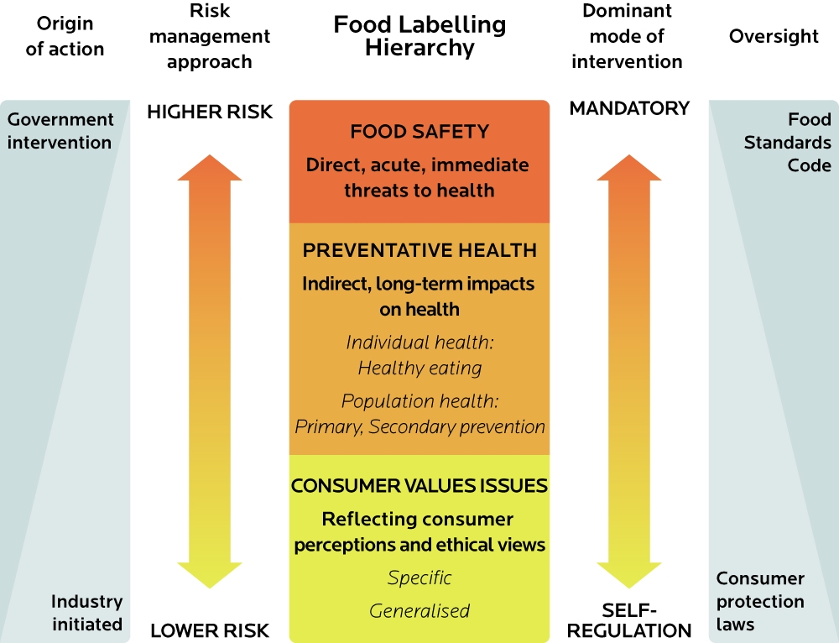

To avoid doubt, ‘food’ refers to foods and beverages, including alcoholic beverages.
Consumers should not be required to access this information online via a link from a food label. However, this does not preclude information that supports consumers to apply the recommendations in the Dietary Guidelines from being provided online or other mediums such as in-store.
Drawn from the Forum’s Response to the Food Labelling Law and Policy Review and Overarching Strategic Statement for the Food Regulation System.
For more information on co-regulatory approaches see Council of Australian Governments’ (COAG) Best Practice Regulation: A guide for Ministerial Councils and National Standard Setting Bodies. Available online.
The Food Labelling Hierarchy recognises the need for a mixture of mandatory and co-regulation for preventative health labelling information. This Policy Principle does not mean that all preventative health information sits at the mandatory end of the Food Labelling Hierarchy and is referring specifically to information that is required for consumers to identify foods that contribute to healthy dietary patterns recommended in the Dietary Guidelines.
Australian National Health and Medical Research Council 2013 and future iterations of this document
Australian National Health and Medical Research Council 2013 and future iterations of this document
New Zealand Ministry of Health 2015 and future iterations of this document.
see New Zealand Ministry of Health Current Food and Nutrition Guidelines
for example “limit intake of foods and drinks containing added sugars” (recommendation 3.3 of the Australian Dietary Guidelines) or “choose and/or prepare foods and drinks with unsaturated fats instead of saturated fats” (Guideline 2.1 of the New Zealand Eating and Activity Guidelines)
Institute of Health Metrics and Evaluation 2018. Global Burden of Disease Study.
Australian National Health and Medical Research Council 2013.
New Zealand Ministry of Health 2015.
Australian Bureau of Statistics 2016. Australian Health Survey: Consumption of Food Groups from the Australian Dietary Guidelines, 2011-12.
New Zealand Ministry of Health 2019. Annual Data Explorer 2018/19: New Zealand Health Survey. Available online.
New Zealand Ministry of Health 2011. A Focus on Nutrition: Key findings from the 2008/09 NZ Adult Nutrition Survey. Available online.
Kantar Public 2017. Healthy Weight and Lifestyle: Exploratory Research Report. Available online.
Dietary patterns are types, combinations and amounts of foods eaten over a period of time.
Grunert, K. G., & Wills, J. M. 2007, ‘A review of European research on consumer response to nutrition information on food labels’. Journal of Public Health, 15(5), 385–399.
Colmar Brunton. 2018, 2018 Health Star Rating monitoring and evaluation: Year 2 follow-up research report. Wellington: Health Promotion Agency.
Glover M, Wong SF, Taylor RW, et al. ‘The Complexity of Food Provisioning Decisions by Māori Caregivers to Ensure the Happiness and Health of Their Children’. Nutrients. 2019;11(5):994.
Food Standards Australia New Zealand 2017, Consumer Label Survey 2015: Food Labelling Use and Understanding in Australia and New Zealand. Available online.
Food Standards Australia New Zealand Act 1991.
For example updated food and nutrient consumption data, Food Standards Australia New Zealand Act, Australia New Zealand Food Standards Code etc.
Drawn from the Forum’s Response to the Food Labelling Law and Policy Review and Overarching Strategic Statement for the Food Regulation System.

