

Principles and protocols for the development of

Food Regulation Policy Guidelines

May 2002 as amended in March 2004, May 2007, May 2008 and August 2019

This guide should be read in conjunction with the Food Regulation Policy Framework. It is essential that this document is provided to all officers that are involved with the development of Food Regulation Policy.

# Food Regulation Policy Framework

## Introduction

The Food Regulation Policy Framework (the Policy Framework) (Diagram 1) sets out the process for identifying and assessing a potential food regulatory issue and determining the appropriate **policy response**. The Framework was established to guide policy development on behalf of the Australia and New Zealand Ministerial Forum on Food Regulation (the Forum). Policy Guidelines developed by the Forum must be taken into account by FSANZ when developing or reviewing food standards. The Framework is designed to be flexible and non-linear and allows for a proportionate approach.

This document outlines the principles behind the Framework and explains the steps in the process. It is not intended to be prescriptive: rather the approach needs to be tailored to the particular issue. It is intended to foster a responsive approach to identifying issues that require coordination across the Food Regulatory System (the System).

**Diagram 1**

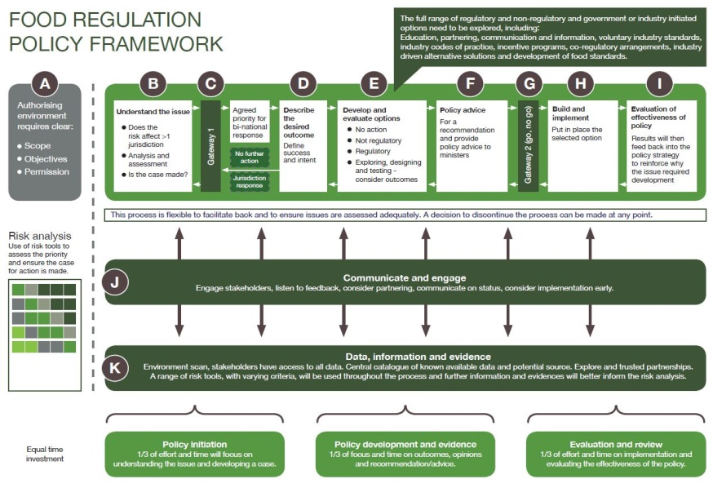

## The Principles

The Food Regulation Standing Committee (FRSC) will uphold the following principles in policy development:

### Leadership

The Forum is the decision maker in the System. FRSC provides policy advice to the Forum. FRSC has the responsibility of oversighting and guiding policy development; policy leads and working groups appointed by FRSC should ensure that policy options are strategic. FRSC will provide strategic links between policies under development.

FRSC plays a key role in engaging with Ministers, stakeholders, other parts of the regulatory system and other parts of government. The Implementation Subcommittee for Food Regulation (ISFR) and Food Standards Australia New Zealand (FSANZ) will have key roles, expertise and evidence to contribute to the process. Project leads should lead the work with an open mind and not be biased towards a specific outcome. Project leads should consult with other jurisdictions and ensure a whole of System approach is developed.

### A Flexible Process

The policy process is flexible and non-linear. A proportionate approach should be adopted. In going through each step and gateway, the approach taken needs to be tailored to the particular issue. Where the Framework is applied it is important to be aware that the process can be discontinued, deferred, referred or merged with another processes at any stage as more evidence and stakeholder information is obtained. FSANZ is responsible for the development and assessment of specific risk management tools such as non-intervention, self-regulation, co-regulation or regulation. If at any stage of the process it is decided that Policy Guidance is not required, the issue can be referred by the Forum to FSANZ with a request to raise a Proposal.

### Timeliness

* FRSC will deliver recommendations for Ministers, industry and other stakeholders in a timely fashion, accounting for the level of risk posed, and the need for in-depth investigation of an issue. Wherever possible FRSC will align and link consultation processes to lessen stakeholder impost and the potential for consultation fatigue.

### Risk analysis

Risk analysis will play an important role in the decision-making process. A range of tools may be used to assess risk. For example, political risk, feasibility, and broader public health risks may be taken into account. Further information and evidence may become available throughout the process to better inform the risk analysis. The risk analysis may also inform the process.

### Transparency

The policy development process has been documented and is available on the [Food Regulation Website](http://foodregulation.gov.au/internet/fr/publishing.nsf/Content/Food-policy-framework). It clearly informs stakeholders about actions being taken and the points at which stakeholders can engage with FRSC.

## Discussion of Steps

Each step in the Policy Framework process is an important component in reaching the best outcome in relation to the issue. Consideration needs to be given to the nature and complexity of the issue at an early stage and the steps of the policy process applied appropriately and proportionally.

Information on each step is discussed below. Note that not all issues identified and discussed by FRSC will go through each step and the process can be discontinued, deferred, referred or merged with another process at any stage as more evidence is gathered and stakeholder consultation occurs.

Different skills will be required at different points in the process. These will include negotiation, facilitation, strategic thinking, listening, innovation, policy analysis and technical skills. FRSC will draw upon its members and stakeholders for these skills.

### Step (a) - Identification of Issues and Authorising Environment

Issues that may be considered within the Policy Framework can be initiated through a number of pathways including discussion at FRSC, a request from Ministers, an issue raised with FSANZ or from ISFR. Diagram 2 provides an outline of how this could work. If FRSC authorises further work the scope, objectives and the way forward should also be agreed.

**Diagram 2**

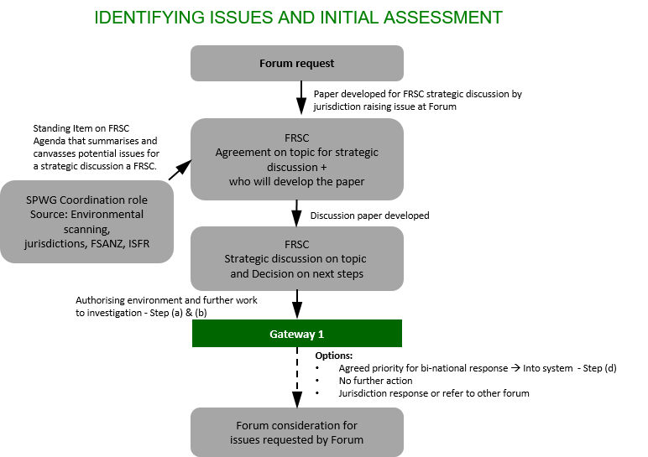

### Step (b) - Understand the Issue

The objective of this phase is to have sufficient understanding of the issue to enable a decision to be made at the first gateway (c). This is intended to be a short, sharp assessment to ensure a full understanding of the issue (problem) risks, challenges and opportunities. To foster genuine, effective two way engagement, it is at this step that stakeholder discussion should be initiated. This will lead to a better understanding of the problem and its impacts. Evidence collected will feed into a preliminary risk assessment that is to be decided and have sufficient justification to demonstrate whether further work on the problem is justified.

Engagement with stakeholders at this stage will need to be carefully managed to ensure that the consultation does not create expectations that an intervention of some kind is assured.

While the problem needs to be articulated at this stage of the process it should be defined at a high level to avoid overlap with other policies under development or with the food standard development process. The problem definition in itself should not steer towards a specific solution for example, the use of the word labelling.

The output from this stage will be a paper to FRSC describing the issue, how the issue impacts jurisdictions, industry and/or the community, the nature and extent of the risk and any evidence to demonstrate market failure. Who else may deal with the issue and the impacts of not addressing the issue should also be assessed. It will recommend whether to proceed or not. This paper could be considered out of session to ensure a timely response. If the Forum has requested action, a paper to the Forum would be required where the recommendation is not to proceed or the responsibility for action belongs elsewhere.

### Step (c) - First Gateway

This is a decision point on the following 1) Is there sufficient evidence, justification and risk to proceed with the matter; and if so 2) does it warrant the development of a Policy Guidance or is the next step the development and assess specific risk management tools and as such should be referred to FSANZ? Referral of issues to FSANZ requires Forum agreement and can occur with or without Policy Guidance. If the Forum seeks a specific outcome from FSANZ (e.g. a mandatory standard) then a Regulation Impact Statement (RIS) must be developed by FRSC and considered by the Forum before a specific outcome can be requested.

However, the Forum can ask FSANZ to consider an issue and determine the appropriate response without the development of a RIS at this stage.

If FRSC has agreed to proceed with the development of Policy Guidance then the process could continue without the need to delay action. If this is deemed appropriate, an update only would be provided to the next Forum meeting. All other decisions are the responsibility of the Forum.

### Step (d) - Describe the Desired Outcome

This step is focussed on what success would look like. A stakeholder analysis should be undertaken during the early stages of this step. Understanding what FRSC is trying to achieve at this point will also assist in evaluating the success of the intervention and where necessary, gathering data that will provide a benchmark to demonstrate the impact of the intervention. It will also clearly describe what the intent is, building on the initial assessment and consulting further with stakeholders. The evidence and assessment will provide the basis for the next step.

At this stage the Office of Best Practice Regulation (OBPR) (and through them the New Zealand Treasury Regulatory Impact Analysis Team (TRIAT)) would be informed that an issue is under consideration. To avoid delay during later stages a process for stakeholder consultation will need to be agreed with OBPR and / or TRIAT. OBPR conducts a Preliminary Assessment to determine whether a RIS will be needed. Detailed [guidance material](https://www.pmc.gov.au/resource-centre/regulation/australian-government-ris-preliminary-assessment-form-ris-required) has been developed to assist with this process. Enough information needs to be provided to help OBPR understand the nature of the policy issues. OBPR will response within 5 working days.

If a RIS is required FSANZ should be involved so as to avoid duplication that may have to be undertaken by them during any later process.

### Step (e) - Develop and Evaluate High Level Options

The aim of this stage is to identify the best tool/s that achieves the desired outcomes. This is an iterative stage where high level policy options are developed and tested. Innovative thinking is required and the range of options should not be constrained. Testing will often show failure of an idea but through failure there is an opportunity to learn and build. Obstacles in current thinking may need to be overcome when considering what is desirable, possible and viable.

Implementation issues, including costs, viability and resources, must be a key consideration at this point and ISFR input can be requested.

This stage should be undertaken in collaboration with stakeholders that are affected. Stakeholder consultation may occur through a variety of methods, including the development and release of a formal consultation paper and request for stakeholder submissions. Where a formal stakeholder consultation process occurs, a Policy Options Paper will be prepared and released to stakeholders for feedback and advice.

OBPR has [developed guidance material](https://www.pmc.gov.au/resource-centre/regulation/best-practice-regulation-guide-ministerial-councils-and-national-standard-setting-bodies) to assist ministerial councils with the development of RIS’s. Officers are strongly encouraged to follow this guidance to avoid delay during the required Assessment process.

The aims of the Policy Options Consultation Paper are to:

* present issues and arguments in an objective, clear and succinct manner;
* present a range of positions and options for comment;
* generate public discussion;
* collect additional information and data;
* elicit broad community support;
* gain an understanding of community views; and
* create high level awareness with stakeholders.

If a RIS is required it needs to be prepared consistent with the advice set out in the Best Practice Regulation: [A guide for ministerial councils and national standard setting bodies](https://www.pmc.gov.au/resource-centre/regulation/australian-government-guide-regulation). The development of a RIS requires significant time and resources. RIS’s require formal assessment by OBPR at two different points during their development. These are the **Early Assessment** and **Final Assessment** stages. An Early Assessment is undertaken before the commencement of the consultation process. If the Early Assessment finds your costings inadequate or your consultation plan unsatisfactory, OBPR will advise on the areas that need to be addressed, otherwise your RIS could be found to be non-compliant at the Final Assessment stage.

In New Zealand the RIS should meet the requirements of the linked [guide](https://treasury.govt.nz/information-and-services/regulation/impact-analysis-requirements-regulatory-proposals). The following RIS processes apply:

1. early engagement with Treasury. This involves testing early thinking around problem definition and the identification of options undertaken after tentative decisions are taken to pursue action or to commission a policy project but before committing to a particular approach; and
2. a full RIS which is subject to quality assurance either by the RIS Quality Team at Treasury or designated independent panels or individuals.

The policy options presented in the Policy Options Consultation Paper or Consultation RIS should:

* be clear and unambiguous;
* include the criteria by which options have been assessed (these are generally expressed as High Order and Specific Policy Principles and should link back to the issue of ‘what are you trying to achieve);
* clearly articulate all options to be considered;
* further develop the options to be considered, including an analysis of the advantages and disadvantages including potential implementation issues and costs identified;
* where relevant, discuss any options that have not been further explored and provide reasons why; and
* invite comment on the option/s being considered.

The table below can be used as a guide to consider what constitutes a proportionate risk-based approach for the advertising of public consultation. Alternative approaches can be proposed. Funding needs to be agreed by FRSC.

| Option | Advertising Option |
| --- | --- |
| 🡩🡩🡩🡩 | * one national Australian newspaper; * two national New Zealand newspapers; * one newspaper in each State/Territory; * selected local newspapers in each State/Territory; * notice placed on the Food Regulation Secretariat (FRS) website; and * email to all stakeholders on the FRS database. |
| 🡩🡩🡩 | * one national Australian newspaper; * two national New Zealand newspapers; * one newspaper in each State/Territory; * notice placed on the Food Regulation Secretariat (FRS) website; and * email to all stakeholders on the FRS database. |
| 🡩🡩 | * one national Australian newspaper; * two national New Zealand newspapers; * notice placed on the Food Regulation Secretariat (FRS) website; and * email to all stakeholders on the FRS database. |
| 🡩 | * targeted consultation with all impacted groups including consumer, public health, industry and government. |

A minimum of period of 6-8 weeks should be allowed for public consultation. The Food Regulation Secretariat will coordinate the advertising and the consultation process.

### Step (f) - Policy Advice

Following the completion of the consultation process, the responsible project lead or working group will collate all stakeholder submissions into a summary document that fairly and accurately represents the views expressed in all submissions received by the working group. This is intended to become a published document after Forum approval.

To assist in the identification of any emerging themes or issues from particular stakeholder groups, the summary should present the results of stakeholder consultation in categories of respondents, such as consumer; food industry; government and public health.

Assessment of the options should be based on how well they achieve the desired outcome, and the impacts.

The Final Assessment by OBPR can only be done after consultation has been completed when all seven RIS questions have been answered in full. In addition to checking your costings and consultation process, OBPR will assess your RIS against the question: Does the analysis support an informed policy decision?

A paper describing the outputs from each step and the rationale for the recommended option to be pursued would initially be discussed at FRSC and agreed for submission to the Forum.

If the recommended option is to develop or amend a standard, consideration should be given on the need for Policy Guidelines. If this is the case the Policy Guideline needs to be clear, comprehensive and consistent but should not be so prescriptive that it specifies the details of standards to FSANZ, and therefore cause potential conflict with the procedures that FSANZ undertakes in developing standards.

**The draft Policy Guideline should outline the agreed policy principles and the recommended policy option. A Food Regulation Policy Guideline should:**

* be consistent with the FSANZ Act;
* reflect the application of the Australia New Zealand Food Standards Code to the whole food supply chain (Australia only);
* take into consideration existing law;
* prioritise policy principles, where appropriate;
* be clear, concise and unambiguous;
* be evidence based wherever possible;
* be developed with appropriate technical and scientific input;
* be developed in a level of detail commensurate with the complexity and sensitivity of the policy issue;
* take into account economic impacts and consideration of any relevant social or cultural impacts;
* be developed with appropriate consultation;
* take into account implementation requirements; and
* take into consideration the potential regulatory impact of the policy.

### Step (g) - Second Gateway

Ministers decide on action recommended by FRSC.

### Step (h) - Build and Implement

The responsibility and process under this step will be dependent on the decision by Ministers. Implementation may be on a trial basis where the option does not involve development of a standard. Engagement with stakeholders will continue to be important to gain acceptance and to finalise the design that is both effective and practical.

### Step (i) - Evaluation of Effectiveness of the Policy

This step will continue to involve stakeholders and will utilise the initial assessment of the issue and any benchmarking data. It will inform any modifications that may be required or if there is a need to move to increased government intervention. The new stakeholder engagement and partnership approach should encourage open and honest feedback that will assist evaluation without it necessarily having to be a formal, resource intensive process.

The whole process is supported and underpinned by (j) Communication and engagement and (k) Data, information and evidence.

### Step (j) Communication and engagement

Early and ongoing stakeholder consultation is a key feature of the process. Stakeholder consultation throughout the process will support an in-depth understanding of the issue and associated risks, and promote a collaborative approach to identifying an appropriate and considered response. FRSC will engage a range of stakeholders depending on the step in the process. Initial stakeholder engagement will explain how the process will proceed and how they will be consulted. Principles for stakeholder engagement will be based on the Partnership Principlesagreed to by FRSC on 16 March 2015 (Attachment A). Consultation will be undertaken consistent with the Consultation Guidelines outlined in the COAG document: Best Practice Regulation: [A guide for ministerial councils and national standard setting bodies](https://www.pmc.gov.au/resource-centre/regulation/best-practice-regulation-guide-ministerial-councils-and-national-standard-setting-bodies). Information received from stakeholders during consultation needs to be shared and taken on-board by other related project leads / working groups and FSANZ. This will signal to stakeholders that the System is coherent and that they have been heard.

### Underpinned by (k) data, information and evidence

Data and evidence will be gathered and analysed at each stage in the process to continually inform and enrich the decisions being made. Where data is not commercial-in-confidence, it should be transparent to stakeholders so that they can fill gaps or dispute evidence. The quality of the partnerships developed will impact on the extent and ease of gathering data. Linkages between projects needs to be recognised early to ensure that data gathering is coordinated to avoid duplication.

**Attachment A**

## Partnerships

In 2015 FRSC adopted the collaborative partnership model as the basis for future partnerships. The guiding principles and measures of success for this model are explained below.

### Definition

Collaborative partnerships are non-legal working relationships between the public and private sectors to meet a common objective or goal. They are used to provide knowledge exchange or collective leverage resources for a specified goal, where the risk is not transferred between partners.

*Two examples of collaborate partnerships within the trans-Tasman food System are the Health Star Rating System and the Pregnancy Warning Messages on Alcoholic Beverages.*

### Operating principles

The System has adopted the following principles outlining when partnerships should be established, pre-conditions for their success, and key characteristics of effective partnering.

### When are partnerships likely to be successful?

Partnerships are most appropriate in the following situations:

* when the needs of individuals, organisations, governments and countries are served by working towards collective goals and harmonisation of approach;
* when collaboration can achieve a measurable social benefit, in terms of societal health or economic development; and
* when skills, knowledge and resources of individual partners complement and enhance their collective capabilities.

### Pre-conditions for effective partnerships

When establishing a partnership the following preconditions apply:

* national need for effective collaboration and ownership;
* clear and measureable objectives of the effectiveness of the partnership;
* an open mind-set and expectation of willingness to cooperate;
* commitment, trust and agreement to mutual respect;
* positive and progressive leadership;
* good governance and transparency; and
* qualification (by experience, resources and commitment) of actors involved.

### Setting up partnerships

A Partnership agreement should be basis on shared vision and objective. The agreement should:

* include consideration of partnership roles and, the decision-making process;
* develop and maintain trust and mutual respect;
* be clear about risks and rewards for all partners; and
* provide for evaluation and monitoring of the effectiveness of partnership arrangement, and the outcomes of decisions.