|  |
| --- |
|  |
| **Australia’s Foodborne Illness Reduction Strategy 2018‒2021+** |
|  |
| A strategy to reduce foodborne illness in Australia, particularly related to Campylobacter and Salmonella |
| **CONSULTATION DOCUMENT** |
|  |
|  |
|  |

**Australia’s Foodborne Illness Reduction Strategy 2018–2021+**

**Background and context**

In April 2017 the Australia and New Zealand Ministerial Forum on Food Regulation (the Ministerial Forum) agreed the food regulation system is producing strong food safety outcomes overall, and identified three priority areas for 2017–2021 to further strengthen the system.

One of these priorities is to reduce foodborne illness, particularly related to *Campylobacter* and *Salmonella*, with a nationally-consistent approach. Ministers requested the development of an Australian strategy, noting New Zealand has an existing *Campylobacter* strategy.

This strategy is to be developed in collaboration with industry, includes improved transparency through monitoring across the food chain, be based on contemporary evidence, and engages the community. This consultation document has been developed by the Food Regulation Standing Committee to facilitate the collaborative development of the strategy.

Foodborne illness management currently occurs at an individual jurisdictional and business level. A nationally-consistent approach is required to effectively reduce foodborne illness. Success requires a concerted effort, collaboration and partnerships across the food supply chain.

In November 2017 the Ministerial Forum gave in‑principle support for the framework that outlines the vision, approach and objective for Australia’s Foodborne Illness Reduction Strategy for reducing foodborne illness in Australia. This framework is included on the next page.

The consultation for the development of the associated national strategy commenced on 12 February 2018 and will close at **Thursday 29 March 2018**. Submissions that address the consultation question can be submitted to:

[foodregulationsecretariat@health.gov.au](mailto:foodregulationsecretariat@health.gov.au), or via post: Submissions – Foodborne Illness Reduction Strategy, C/- Food Regulation Secretariat, GPO Box 9848, MDP 707, Canberra ACT 2601.

Important notice to all submitters: All submissions are subject to the *Freedom of Information Act 1982* in Australia and the *Official Information Act 1982* in New Zealand. If you consider that all or part of your submission should not be released, please make this clear when making your submission and indicate the grounds for withholding the information.

A summary of submissions will be produced and published at the [Food Regulation website](http://www.foodsecretariat.health.gov.au/).

Copyright in an original submission resides with the copyright owner of that submission, but the act of making a submission will grant the Australian Government a licence to use the submission for the purpose of making a summary of the submission for the website and for future further development and implementation of the strategy.

Consultation will be multi-faceted and will utilise existing networks. States and Territories will consult at the local level and Food Standards Australia New Zealand will facilitate national roundtables that bring together industry sectors. The following contacts can provide further information:

* Food Regulation Secretariat – [foodregulationsecretariat@health.gov.au](mailto:foodregulationsecretariat@health.gov.au)
* Food Standards Australia New Zealand – [amanda.hill@foodstandards.gov.au](mailto:amanda.hill@foodstandards.gov.au) or (02) 6271 2632
* Australian Capital Territory – ACT Health – Health Protection Service – [EHPolicy@act.gov.au](mailto:EHPolicy@act.gov.au)
* South Australia - Food and Controlled Drugs Branch – [HealthFood@sa.gov.au](mailto:HealthFood@sa.gov.au) or (08) 8226 7100
* New South Wales Food Authority Helpline – [contact@foodauthority.nsw.gov.au](mailto:contact@foodauthority.nsw.gov.au) or 1300 552 406
* Tasmania - Biosecurity – (03) 6777 2197
* Western Australia – Department of Health – [mark.fallows@health.wa.gov.au](mailto:mark.fallows@health.wa.gov.au) or 08 9388 4990
* Queensland – Department of Health – [foodsafety@health.qld.gov.au](mailto:foodsafety@health.qld.gov.au) or (07) 332 89323
* Victoria – Department of Health and Human Services - [gabrielle.allen@dhhs.vic.gov.au](mailto:gabrielle.allen@dhhs.vic.gov.au)
* Northern Territory – Department of Health - [tracy.ward@nt.gov.au](mailto:tracy.ward@nt.gov.au) or (08) 8922 7469
* Australian Local Government Association – [monica.telesny@alga.asn.au](mailto:monica.telesny@alga.asn.au) or (02) 6122 9433

Submissions and outcomes from consultation meetings will be used to further develop the strategy that will be in line with the vision, approach and objectives agreed by the Ministers.

**Vision, approach and objectives**

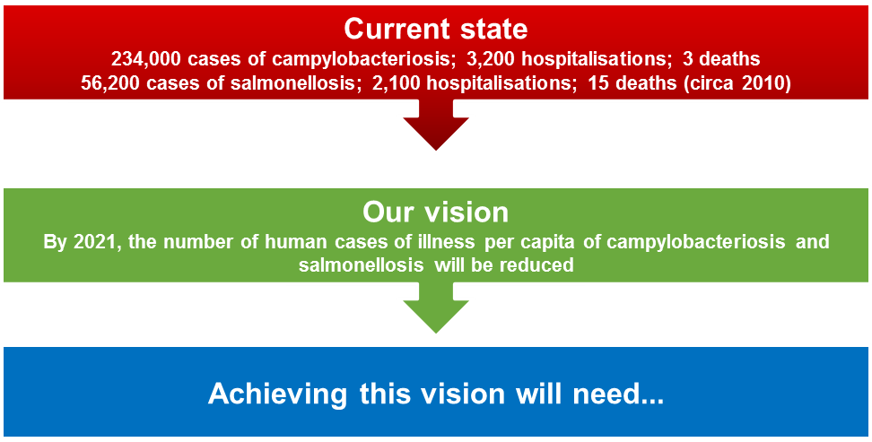

1. **action at all points along the food supply chain**
2. **working closely with industry to develop interventions and drive reform**
3. **research and evidence driving innovation**
4. **a revised regulatory system that focuses effort on critical outcomes and food safety culture**
5. **to be targeted to the most relevant parts of the food supply chain; that is, the poultry, egg and horticulture (leafy greens, sprouts, melons and berries) industries; food service, and consumers**

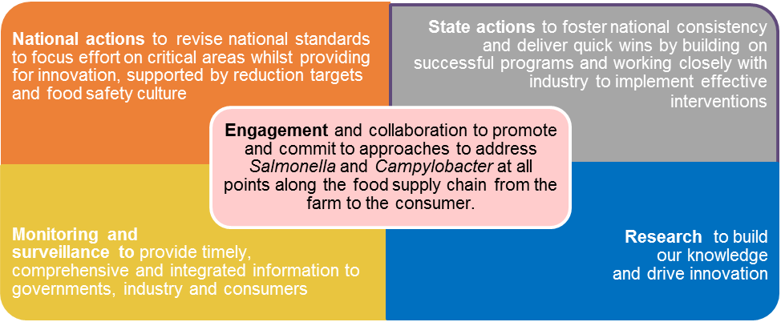

**This will involve…**

# PART B – CONSULTATION DOCUMENT

This consultation document includes relevant background, current activities and some ideas on potential new activities. The purpose of the consultation is to explore with our partners and stakeholders what actions should be undertaken by each of us to achieve the goal.

We would like to explore the key challenges to managing the risks of foodborne illness for your sector.

Four core areas of activity are suggested for the strategy. Are there any other aspects that should be covered by the strategy?

What initiatives/activities are already underway in your sector that could contribute to a national strategy?

What additional activities do you suggest should be included?

How could the evidence-base for decision-making be strengthened?

## Why a national strategy?

*Campylobacter* is the most commonly notified cause of gastroenteritis in Australia. The report *Foodborne illness in Australia – annual incident circa 2010* estimated the median number of domestically acquired cases of gastroenteritis due to *Campylobacter* (circa 2010) to be 234,000 cases, including 3,200 hospitalisations and 3 deaths (77% of these cases were considered to be via foodborne transmission).

Foodborne illness caused by *Salmonella* has been significantly increasing over the past 20 years and, compared to many similar countries, we have one of the highest rates (Figure 1). There are an estimated 56,200 cases of salmonellosis (2,100 hospitalisations and 15 deaths) with 72% of these considered to be foodborne.

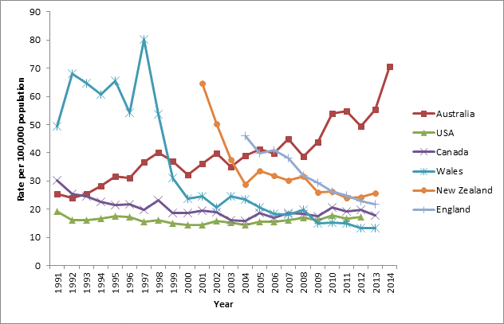

*Figure 1: Salmonellosis notification rates (all serotypes combined) in selected countries*

State and territory health, agriculture and food authorities, and industry have implemented a range of regional risk management activities. At a national level, since 2013, key food regulatory interventions have included the implementation of primary production and processing standards, particularly in the poultry and egg industry sectors. Some states are also developing state-based foodborne illness reduction strategies.

Foodborne illness is not a local issue and a coherent approach is required to tackle the challenges effectively. The experience of countries (New Zealand, United Kingdom, United States of America, and European Union) that have focussed on reducing foodborne illness nationally indicates the best opportunity for success uses a targeted and coordinated approach with set health goals, and follows a structured risk management framework.

## Goal

The aim of *Australia’s Foodborne Illness Reduction Strategy* 2018-2021+ is to reduce the number of food-related human cases of campylobacteriosis and salmonellosis in Australia.

The goal could be expressed in a number of ways e.g. qualitative, quantitative or reduction in outbreaks. In order to articulate more quantitative measures, we need better epidemiological and surveillance information and data on the impacts of *Salmonella* and *Campylobacter*.

Implementation of the strategy presents an opportunity for gaining such information on notification rates and contributing factors.

### To achieve this goal, we will need…

#### action at all points along the food supply chain from the farm to the consumer

The food chain for each commodity can generally be represented as follows:

Each stage contributes in a particular way to the level of pathogen in the end product, whether it is action on the farm, how a product is processed, or how it is handled by retailers and the consumer.

Interventions at different points will have a different impact on the final outcome and this can vary for each pathogen and for different industries.

#### working closely with industry to develop interventions and drive reform

Industry buy-in will be achieved through meaningful engagement, sector by sector. Reform will also be successful if it enhances industry productivity. Accordingly, this strategy commits to establishing ongoing fora with industry to identify potential areas of improvement and to support the building of food safety culture within the food sector (see below).

#### maximise opportunities created by digital innovation and transformation

Digital transformation is now reshaping all aspects of society and the food industry is no exception. The connectivity of people with businesses; big data and analytics, artificial intelligence and the internet of things are trends that are rapidly disrupting businesses. These developments provide great opportunities to improve food safety by empowering the consumer and changing the relationships between businesses and regulators. Through effective engagement with innovative businesses, this strategy can incorporate these developments into practical solutions to food safety risks.

#### building a regulatory system that expects and promotes a food safety culture

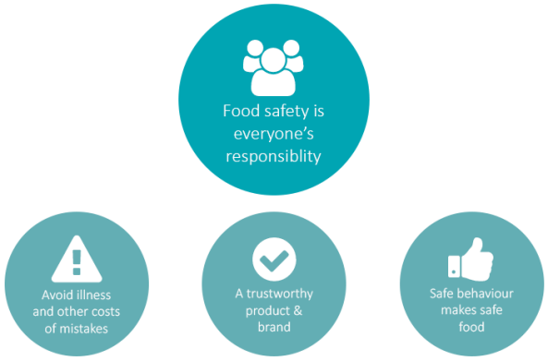

For regulators, it means that businesses achieve food safety outcomes because of their own commitment to food safety rather than relying on audits or inspections to identify risks, and penalties to enforce compliance. The Food Standards Code specifies minimum expectations to ensure food safety, and the broader food regulatory system promotes and rewards businesses with high-performing food safety culture.

#### a fit-for-purpose regulatory system that focuses effort on critical areas for intervention

Standards should align with and support measures being developed by industry to improve food safety outcomes.

As innovative measures are identified, and shown to be relevant and have impact, the regulatory system needs to adapt and adopt these measures so improvements are taken up across the entire food industry.

#### research and evidence driving innovation

Actions taken under this strategy will be guided by evidence and research. Through the support of industry, jurisdictions and research bodies, universities are doing research that can improve the measures taken to control risks in the food chain.

To build our collective knowledge and drive innovation, it is essential to share knowledge and experience across the food regulatory system and with industry. New ideas and practices are already being considered, and this strategy needs to continue to support this innovation. We will also need to actively support the evaluation of new practices and dissemination of evidence.

By building linkages with researchers, it is hoped that research continues to inform practice and equally, that research priorities are informed by needs identified by jurisdictions and industry.

Shared Vision + Coordination and Collaboration + Evidence-based interventions

Partnerships
+
Tools and Processes
+
Research and Innovation

## The five core areas

Our national strategy to reduce the rate of foodborne illnessrelated to*Salmonella* and *Campylobacter* will be targeted to the most relevant parts of the food supply chain; that is, the poultry, egg and horticulture (leafy greens, sprouts, melons and berries) industries; food service, and consumers.

The strategy will be achieved by actions in five core areas – monitoring and surveillance, research, national actions, state actions and engagement. Each of these areas is equally important to the strategy’s success.

These actions include existing strategies that can be adapted and new initiatives that can be progressed in the short (mid 2018 - mid 2019) to mid to long term (mid 2019 – 2021+). Table 1 provides a summary of these proposed actions.

### National actions

#### Proposed short-term actions (mid 2018 - mid 2019)

* Resources to support food safety culture within the food sector

Food safety culture in a business is how everyone (owners, managers, employees) thinks and acts in their daily job to make sure that the food they make or serve is safe. It's about having pride in producing safe food every time, recognising that a good quality product must be safe to eat.

A strong food safety culture comes from people understanding the importance of making safe food and committing to doing whatever it takes, every time. It starts at the top but needs everyone's support across the business.

FSANZ has developed information and resources for food businesses on food safety culture.

FSANZ will continue leading national activities with a broad range of stakeholders including food regulatory agencies from all levels of government and large and small food businesses, to promote and improve food safety culture.

Initiatives to support this could include:

* Upskilling of authorised officers to close the gap between knowledge and application
* Working with educational institutions to recognise the importance of food safety culture in formal training
* Fresh produce food safety management

Managing *Salmonella* will require the control of food safety risks in horticultural supply chains. New South Wales has had specific regulatory measures in place targeting high risk horticultural processing businesses for some time. The Food Regulation Standing Committee (FRSC) is consulting with industry on fresh produce food safety management. The information gathered from these discussions will assist FRSC to develop informed, contemporary policy advice that ensures that effective systems, interventions and partnerships are in place, and are maintained, to prevent and respond to foodborne illness involving fresh produce.

Once developed, actions arising from this process will be implemented consistently across all jurisdictions.

#### Proposed mid to long-term actions (mid 2019 – 2021+)

* Implement the Ministerial Policy Guideline on Food Safety Management for the General Food Service and Closely Related Retail Sectors to deliver nationally-consistent food safety management arrangements in these sectors.

Significant resources have been applied to this sector in all jurisdictions and national discussion and consideration of further regulatory and non-regulatory measures is progressing under the FRSC/ISFR Food Safety Management Working Group. Integrating the outcomes of this work into the national strategy is a priority.

* Review the national food safety standards and primary production and processing standards for poultry and eggs in the Food Standards Code to modernise and enhance effectiveness

Food safety is covered by several standards in the *Australia New Zealand Food Standards Code (*Food Standards Code*).* These standards aim to lower the incidence of foodborne illness by strengthening food safety and traceability throughout the food supply chain, from paddock to plate. The standards are:

* + Food Safety Standards ([Chapter 3 – Australia only](http://www.foodstandards.gov.au/foodsafety/standards/Pages/Food-Safety-Standards-(Chapter-3).aspx))
  + Primary Production and Processing Standards ([Chapter 4 – Australia only](http://www.foodstandards.gov.au/foodsafety/standards/Pages/Primary-Production-and-Processing-(PPP)-Standards-(Chapter-4).aspx))
  + Microbiological Limits for Food ([Standard 1.6.1](http://www.foodstandards.gov.au/foodsafety/standards/Pages/Microbiological-limits-for-food-(Standard-1.6.1).aspx))

The Food Safety Standards have not been reviewed since their development in 2000. These standards provide a solid foundation of requirements to support the production of safe food (specifically in Standard 3.2.2), however there is lacking the associated measures to integrate these requirements into a risk-based system.

The review of the egg and poultry meat primary production and processing standards is aimed at making the standard easier to understand and to implement across the food chain and will clarify any aspects, where necessary. Work internationally will also inform FSANZ’s review. The Codex Committee for Food Hygiene (CCFH) has also commenced a review of the *General Principles of Food Hygiene* which is the basis for all codes of hygienic practice developed by CCFH.

FSANZ’s review of the role and purpose of microbiological criteria for *Salmonella* will consider whether a food safety objective could be articulated for *Salmonella* (in RTE foods) which links to the goal of the national strategy. A food safety objective can be an important component of a risk-based system of food safety. By setting a food safety objective, competent authorities articulate a risk-based limit that should be achieved operationally within the food chain, while providing flexibility for different production, manufacturing, distribution, marketing, and preparation approaches.

* Review compliance provisions in the *Model Food Act* to provide greater clarity on the role of food safety management tools

The *Model Food Act* provides the overarching legislative framework for state and territory Food Acts and it is timely to consider the currency of the compliance provisions. The review of the food safety standards in the Food Standards Code and the food safety management work in the food service and closely related retail sectors, once progressed, could inform these considerations.

### State actions

#### Proposed short-term actions (mid 2018 - mid 2019)

* Establish mechanisms in each jurisdiction to support industry engagement

All jurisdictions will continue working on their existing and planned activities to address *Salmonella* and *Campylobacter* through the supply chain and will use their specific local stakeholder relationship processes to extend the reach of actions under this strategy. There is already substantial activity in this area underway in several states and territories.

States and territories will use their processes to trial new concepts and report outcomes to their counterparts, to foster national consistency in approach. States and territories commit to continue this information-sharing activity, to ensure that where practicable, outcomes and learnings are filtered into national processes. This commitment will enable the food regulation system to adapt and be flexible to a dynamic food business environment.

* Adoption of poultry process hygiene criteria and national performance reporting

Industry and food regulatory agencies recognise that reducing the occurrence of *Campylobacter* on raw chicken meat is an important strategy to reduce campylobacteriosis. *Campylobacter* does not tend to grow at the point of food service or in the kitchen, so reducing the *Campylobacter* load on chickens in early points of the chain does seem to reduce the number of illnesses in the community. These efforts go beyond the minimum requirements of the poultry primary production and processing standard of the Food Standards Code.

In 2015-2016, Food Standards Australia New Zealand (FSANZ) developed nationally consistent *Campylobacter* targets for raw poultry meat leaving the processor. Several jurisdictions have been actively working with poultry processors to identify and control critical processing operations to reduce outgoing loads of *Campylobacter*. Efforts will now shift to national adoption of these poultry process hygiene criteria and national performance reporting.

* Coordinated effort at retail/food service to reduce impact of raw egg foods

For *Salmonella* on the other hand, there is clear evidence from recent outbreaks associated with eggs that the behaviour of food services was the critical factor in increasing the number of people who became ill.

This pathogen requires control steps to be applied across several different parts of the supply chain. Actions to control the prevalence of *Salmonella* will be focussed on the poultry industry (layers and broilers), and in the use of eggs in the retail/food service industries, and in home settings.

Foods that contain raw or lightly-cooked egg are often used in restaurants, cafes, bakeries, catering and manufacturing food businesses and need extra care, as they can cause food poisoning if not handled correctly. In order to ensure the food is safe to eat, special attention must be given to the preparation, storage and handling of eggs and raw egg products, to prevent the growth of *Salmonella*.

It is also proposed to developing a national and consistent approach to the recall of eggs.

#### Proposed mid to long-term actions (mid 2019 – 2021+)

* Consolidate food safety information across jurisdictions and establish a targeted communication plan for key risk areas
* Establish targeted communication plans for education/training providers

Targeting of guidance and education for industry and consumers can be improved by consolidating existing and planned food safety information activities across jurisdictions. A communication plan will target ongoing issues related to consumer food handling behaviours and consistency of messaging on the role of handling storage and preparation of poultry, and eggs including the use of raw egg products.

### Monitoring and surveillance

The outcome is to have a monitoring and surveillance system that provides timely, comprehensive, systematic and integrated information to governments, industry and consumers so that appropriate public health and safety action can be taken. This system could nationally integrate surveillance data of foodborne salmonellosis and campylobacteriosis in humans, and data from monitoring of *Salmonella* and *Campylobacter* in food.

With regard to cases of human illness, the Nationally Notifiable Diseases Surveillance System (NNDSS) co-ordinates the national surveillance (from laboratories and clinicians) of more than 50 communicable diseases or disease groups. This includes all notified cases of human salmonellosis and campylobacteriosis in Australia.

Under the NNDSS, notifications are made to state or territory health authorities under public health legislation in their jurisdiction. Data is owned by individual jurisdictions. Computerised, de-identified unit records of notifications are supplied to the Australian Government Department of Health for collation, analysis and publication.

For contaminants in food, monitoring and surveillance occurs at different stages of the food chain and for various reasons. These may include routine testing of primary products, regulatory compliance, market access, verification of food safety programs, and national food surveys. Industry also monitors hazards in foods and data can be collected on a company - or industry-group level. The types of data collected, how it is collected and reported and when and how it is shared differs across government and between industry sectors.

#### Proposed short-term actions (mid 2018 - mid 2019)

* Establish information-sharing arrangements between state and federal agencies and industry to target interventions, inform priorities and monitor progress

Enhancing linkages between the various agencies involved in human and food surveillance activities is a complex issue that cannot be resolved by simply changing the way information is collected or managed. All of this data is not in the public domain but could be accessed through trusted gatekeepers and under proper governance. This will require high-level leadership to drive the process and be supported by information-sharing agreements between state and federal agencies and information sharing arrangements with industry.

#### Proposed mid to long-term actions (mid 2019 – 2021+)

* Interrogate existing public health surveillance data to identify attribution pathways for *Salmonella*

Knowledge of the foods responsible for illness comes mainly from outbreak investigations and case-control studies. Under appropriate information-sharing agreements, we could increase the intelligence from the data currently collected (but not publicly available) to understand trends and risk factors to prioritise the most effective food safety mitigations management for reducing foodborne salmonellosis.

* Conduct a national benchmark study on food handling knowledge, practices and food safety culture to inform education, training and resource development priorities

New data could be generated on how current food handling practices contribute to *Salmonella* and *Campylobacter* transmission, particularly considering new technologies and food trends. In 2001, the Australia New Zealand Food Authority (now FSANZ) commissioned a benchmark study of food handling practices in Australian food businesses before the new food safety standards were introduced. This study explored awareness of safe food handling practices and did on-site surveys of the extent to which these practices are used.

Under the strategy, an expanded national study looking at knowledge, practices and importantly, awareness and commitment to food safety culture could be conducted in 2018 to better understand and identify areas for targeted and collaborative strategies and initiatives. Food safety culture can be measured using a self-assessment survey with pinpointed food safety behaviours.

* Conduct a follow-up national study on food handling knowledge, practices and food safety culture to measure knowledge, application and behavioural change

In 2021, a repeat study on food handling knowledge, practices and food safety culture could be conducted to provide an indication as to how well a business and its employees know of, and deal with, issues related to food safety. Using maturity models, the level of food safety culture could be measured across key capability areas to guide further improvement.

* Evaluate existing surveillance system platforms for compatibility and feasibility to integrate human illness and food safety data.
* Develop options for data sharing and integration across commodities and supply chains.

The aim is to integrate food safety and human illness data to deliver improved information on food safety hazards and public health outcomes. This is a longer-term objective and challenging, as it is not only about willingness to share information (which may be addressed through information sharing arrangements/agreements) but also about the comparability and consistency of data collected by different agencies and industry.

The feasibility of leveraging existing platforms to support centralised data sharing and analyses will be investigated. For example, Victoria’s *Salmonella* Reduction Strategy for 2017-2020 will build on the findings of a previous scoping study and existing data systems to improve the integration of food (industry and council sampling data), human and zoonotic data.

A centralised and integrated system for compiling, trending and analysing data will improve our understanding of the impact of, and management of, *Salmonella* and *Campylobacter*. Trends observed from public health surveillance and outbreak investigations, combined with intelligence from food monitoring and surveillance will be used to target interventions, inform priorities and monitor progress under this strategy.

### Research

Actions taken under with this strategy will be guided by research and evidence. To build our collective knowledge and drive innovation, it will be essential to share knowledge and experience across the food regulatory system, with industry and research bodies.

#### Proposed short-term actions (mid 2018 - mid 2019)

* Establish closer collaboration with existing networks through partnerships and sharing information to identify and influence priorities

Partnering to produce science-based evidence will:

* + target research and development to reduce foodborne illnesses
  + inform policy direction, preparedness and control options
  + deliver diagnostic and surveillance services to help reduce the impact of foodborne threats
  + improve market access, and
  + support sustainable economic growth
* Establish a network of researchers, industry and government to more quickly maximise the value of research findings
* Investigate causes for clustering of *Campylobacter*

We could build stronger linkages with researchers, and coordinate government investment in research. In doing this, research should continue to inform practice and equally, priorities for research will be informed by the needs identified by jurisdictions and industry.

We could maximise the value of research findings early and where appropriate adopt them nationally.

A research network could be established under the FSANZ fellows program[1] to facilitate the sharing of research outcomes between researchers, industry, regulators and the community and develop a national research plan to identify and consolidate key applied research targets.

#### Proposed mid to long-term actions (mid 2019 – 2021+)

* Investigate approaches to obtain better attribution data

We will explore application of geospatial mapping (environmental factors and using postcodes) for improved design of food surveillance and monitoring resulting in better attribution data.

### Engagement

#### Proposed short-term actions (mid 2018 - mid 2019)

* Establish national industry specific forums to support the implementation of measures outlined in this strategy
* Focus on better state and local government engagement

Partnerships with food regulators, the poultry industry and retail sector will be important in addressing *Campylobacter*. We will engage on an on-going basis and work with key stakeholders (the poultry, egg and horticulture industries and food service) to develop and implement targeted and evidence-based activities to address both *Salmonella* and *Campylobacter.* The effectiveness and impact of these actions will be evaluated, both in their specific context as well as in reducing the number of food-related cases of campylobacteriosis and salmonellosis.

Jurisdictional-based stakeholder engagement on options to improve food safety outcomes in the general food service and closely related retail sectors will continue. The experiences and views from those consultations on existing tools and measures likely to have the greatest impact on food safety outcomes will inform further consultations at the national level.

We will continue to raise awareness and improve understanding of appropriate food safety practices in the food service and retail sector and in home settings.

#### Proposed mid to long-term actions (mid 2019 – 2021+)

* Continue working with New Zealand to explore interventions found to be effective for *Campylobacter* control and to understand the similarities and differences in salmonellosis between the two countries.

We will investigate the effectiveness and applicability of New Zealand’s *Campylobacter* national strategy to the Australian context. New Zealand implemented a national risk management strategy for *Campylobacter* in broiler chicken meat following an unacceptably high rate of foodborne campylobacteriosis in 2006, largely attributed to preparation and consumption of poultry meat. Their strategy’s main focus was on targeted quantitative hazard - and risk-based controls along the poultry chain, monitoring performance in meeting targets, safe food handling, and implementing controls with commitment from all sectors involved. New Zealand is now investigating additional transmission routes to further reduce the incidence.

* Investigate the use of technology for targeted consumer education

To ensure our strategy is targeted to consumers’ needs, it will be important to engage effectively with consumers on an ongoing basis, particularly when developing or implementing new interventions. We will seek information from consumers to identify knowledge gaps and behaviours that may be putting them at risk.

* Investigate the utility of a digital engagement platform (social, mobile, cloud and analytics)

We will use a mixed approach that provides flexibility to manage the differences in relationships between stakeholders. We will use a combination of tools including discussion papers, public fora, targeted consultations and social media and investigate ways to provide more opportunity for stakeholder engagement.

## Implementation

The Food Regulation Standing Committee will be the governing body for implementing the strategy and reporting back to Ministers on progress.

Table 1 – Summary of proposed short-term and mid-to long-term actions

Further detail on these proposed activities is provided in the paper.

| **Action areas** | **Proposed short-term actions**  **(mid 2018 – mid 2019)** | **Proposed mid to long-term actions**  **(mid 2019 – 2021)** |
| --- | --- | --- |
| **National** | * Resources to support food safety culture within the food sector * Fresh produce food safety management | * Implement the *Ministerial Policy Guideline on Food Safety Management for the General Food Service and Closely Related Retail Sectors* to deliver nationally-consistent food safety management arrangements in these sectors * Review the national food safety standards and primary production and processing standards for poultry and eggs in the Food Standards Code to modernise and enhance effectiveness * Review compliance provisions in the *Model Food Act* to provide greater clarity on the role of food safety management tools |
| **State** | * Establish mechanisms in each jurisdiction to support industry engagement * National adoption of poultry process hygiene criteria for *Campylobacter* and establish performance reporting * Coordinated effort at retail/food service to reduce impact of raw egg foods * Develop a national food recall system for eggs | * Consolidate food safety information and establish consolidated communication plan * Establish targeted communication plan for education/training providers |
| **Monitoring and surveillance** | * Establish information-sharing arrangements between state and federal agencies and industry to target interventions, inform priorities and monitor progress | * Interrogate existing public health surveillance data to identify attribution pathways for *Salmonella* * Conduct a national benchmark study on food handling knowledge, practices and culture to inform education, training and resource development priorities * Conduct a follow-up national study on food handling knowledge, practices and culture to measure change * Evaluate surveillance systems for compatibility and feasibility to integrate human illness and food safety data * Develop options for data sharing across commodities and supply chains |
| **Research** | * Establish closer collaboration with existing networks through partnerships and sharing information to identify and influence priorities * Establish research/academia, government, industry network to maximise research findings * Investigate causes for clustering of *Campylobacter* | * Explore application of geospatial mapping (environmental factors and using postcodes) for improved design of food surveillance and monitoring resulting in better attribution data |
| **Engagement** | * Establish national industry specific forums to support implementation * Focus on better state and local government engagement | * Continue working with New Zealand to explore interventions found to be effective for *Campylobacter* control and to understand the similarities and differences in salmonellosis between the two countries. * Investigate the use of technology for targeted consumer education * Investigate the utility of a digital engagement platform (social, mobile, cloud and analytics) |

1. The FSANZ Fellows program was developed to create a network of experts who can provide FSANZ with objective expert advice and critical review. The program also helps to develop academic links and networks.